GEF-6 REQUEST FOR PROJECT ENDORSEMENT/APPROVAL
Project Type:
Type of Trust Fund:
For more information about GEF, visit TheGEF.org

part i: project information
Project Title: Integrated Management of Water Resources of the Mira, Mataje and Carchi-Guáitara, Colombia – Ecuador Binational Basins
Country(ies): | Colombia and Ecuador | GEF Project ID: |  | 9566
GEF Agency(ies): | UNDP | GEF Agency Project ID: |  | 5753
Other Executing Partner(s): | Ministry of Environment and Sustainable Development of Colombia (MADS) and Water Secretariat of Ecuador (SENAGUA) | Submission Date:
GEF Focal Area (s): | International Waters | Project Duration (Months) |  | 48
Integrated Approach Pilot | IAP-Cities IAP-Commodities IAP-Food Security |  | Corporate Program: SGP
Name of Parent Program | [if applicable] | Agency Fee ($) |  | 365,750
- Focal AREA STRATEGY Framework and Other Program Strategies
Focal Area Objectives/Programs | Focal Area Outcomes | Trust Fund | (in $)
Focal Area Objectives/Programs | Focal Area Outcomes | Trust Fund | GEF Project Financing | Co-financing
 | Outcome 1.1: Political commitment/shared vision and improved governance demonstrated for  joint, ecosystem-based management of transboundary water bodies.  Outcome 1.2: On-the-ground demonstration actions implemented, such as in water quality,  quantity, conjunctive management of groundwater and surface water, fisheries, coastal  habitats.  Outcome 1.3: IW portfolio performance enhanced from active learning/KM/science/experience sharing |  | 3,850,000 | 45,730,120
Total project costs |  |  | 3,850,000 | 45,730,120
- Project description summary

Project Objective: To promote integrated water resources management (IWRM) in the Mira, Mataje and Carchi-Guáitara river basins shared by Colombia and Ecuador by strengthening the institutional and managerial capacities at the regional, local and community levels for achieving environmental and socioeconomic benefits.
Project Components/  Programs | Financing Type | Project Outcomes | Project Outputs | Trust Fund | (in $)
 |  |  |  |  | GEF Project Financing | Confirmed Co-financing
1. Generation of knowledge, information  management and diagnostic analysis of  the current status of the transboundary  water resources (surface and ground  waters) of the Mira, Mataje and Carchi-  Guáitara binational basins. |  | Outcome 1. Priority transboundary issues affecting quality and quantity of water, its vulnerability to climate change and variability and barriers for IWRM, and their immediate and root causes, have been identified, including a governance and stakeholder analysis to further inform the SAP process. | 1. Transboundary Diagnostic Analysis (TDA) on Mira, Mataje and Carchi-Guáitara basins, based on the secondary information and generation of primary information, including structural causes, future status and dynamics completed and validated. |  | 656,071 | 18,292,048
2. Strategic planning to strengthen governance for transboundary IWRM in Mira, Mataje and Carchi-Guaitara binational watersheds and aquifers | TA | Outcome 2. Priority actions required for achieving IWRM of the Mira, Mataje and Carchi-Guáitara basins identified and integrated to the binational, national and sub-national development plans in both countries. | 2. Strategic Action Program (SAP) adopted by the two countries focused on priority actions (e.g., governance reforms, investments) to address the transboundary issues identified by the TDA. | GEFTF | 582,233 | 9,146,024
3. Capacity building at public, private and community level enabling the shared IWRM of Mira, Mataje and Carchi-Guáitara river basins. | TA | Outcome 3. Improved individual and institutional capacities in both countries to apply IWRM in the binational basins. | 3. Training of key national and subnational stakeholders in key aspects to apply IWRM (water governance and improved operation of water and irrigation boards). | GEFTF | 440,469 | 4,573,012
4. Innovative interventions for testing the socioeconomic and environmental benefits from applying the IWRM at selected sites of the Mira, Mataje and Carchi-Guáitara river basins. | TA | Outcome 4.1. Integrated water resource management and sustainable land use reduce pollution, improve water use efficiency and protect/restore aquatic ecosystems in the Mira, Mataje and Carchi-Guáitara river basins and their aquifers.  Outcome 4.2. Learning generated through replicable innovative interventions supports the SAP development and decision making. | 4.1.1. Three small scale innovative interventions on IWRM to reduce pollution from domestic wastewater, facilitate hydrometeorological data sharing and reduce risk of climate-related landslides.  4.1.2. One pre-feasibility study to catalyse investments to improve the operation of rural water boards.  4.2. Systematization of results, lessons and experience from the project and the innovative interventions in the Mira, Mataje and Carchi-Guáitara basins is available for relevant national and subnational stakeholders, as well as for other projects through participation in IW: LEARN. | GEFTF | 1,977,894 | 12,804,434
Subtotal |  |  |  |  | 3,656,667 | 44,815,518
Project Management Cost (PMC) |  |  |  | GEFTF | 193,333 | 914,602
Total project costs |  |  |  |  | 3,850,000 | 45,730,120
- confirmed sources of Co-financing for the project by name and by type
Please include evidence for co-financing for the project with this form.
Sources of Co-financing | Name of Co-financier | Type of Cofinancing | Amount ($)
Recipient government | GAD Angochagua | Grant | 258,478
Recipient government | GAD Angochagua | In-kind | 5,000
Other | CORPONARIÑO | Grant | 63,677
Recipient government | Government of Nariño | In-kind | 17,396,715
Recipient government | Government of Nariño | Grant | 1,587,935
Recipient government | Ipiales municipality | Grant | 199,149
Recipient government | Ricaurte municipality | In-kind | 10,252
Recipient government | Ibarra municipality | In-kind | 375,566
Recipient government | San Lorenzo municipality | In-kind | 50,000
Recipient government | Tulcan municipality | Grant | 6,636,200
Recipient government | Tulcan municipality | In-kind | 7,819
Recipient government | GAD Carchi | Grant | 2,682,783
Recipient government | GAD Carchi | In-kind | 13,090
Recipient government | GAD Esmeraldas | Grant | 2,741,620
Recipient government | GAD Esmeraldas | In-kind | 10,358
Recipient government | GAD Imbabura | Grant | 4,005,702
Recipient government | GAD Imbabura | In-kind | 35,167
Recipient government | GAD Tufiño | Grant | 33,250
Recipient government | GAD Tufiño | In-kind | 969
Recipient government | SENAGUA | Grant | 1,042,498
Recipient government | MAE | Grant | 1,204,491
Recipient government | MADS | Grant | 5,105,601
Recipient government | MADS | In-kind | 18,426
Recipient government | INAMHI | Grant | 169,229
Recipient government | INAMHI | In-kind | 830,770
Recipient government | IDEAM | In-kind | 800,000
CSO | ALTROPICO | Grant | 375
CSO | WWF Colombia | Grant | 425,000
GEF agency | UNDP Ecuador | In-kind | 20,000
Total Co-financing |  |  | 45,730,120
- Trust FUND RESOURCES Requested by Agency(ies), COUNTRY(ies) and the Programming of Funds
GEF Agency | Trust Fund | Country  Name/Global | Focal Area | Programming of Funds | (in $)
 |  |  |  |  | GEF Project Financing (a) | Agency Fee ^{a)} (b)² | Total  (c)=a+b
UNDP | GEFTF | Regional (Colombia and Ecuador) | International waters |  | 3,850,000 | 365,750 | 4,215,750
Total Grant Resources |  |  |  |  | 3,850,000 | 365,750 | 4,215,750

a ) Refer to the Fee Policy for GEF Partner Agencies

- Project’s Target Contributions to GEF 6 Core Indicators
Update the relevant sub-indicator values for this project using the methodologies indicated in the Core Indicator Worksheet (as used in GEF 7 Endorsement template – Annex E) and aggregating them in the table below. Progress in programming against these targets is updated at mid-term evaluation and at terminal evaluation. Achieved targets will be aggregated and reported any time during the replenishment period. There is no need to complete this table for climate adaptation projects financed solely through LDCF and SCCCF.
Project Core Indicators |  | Expected at CEO Endorsement
1 | Terrestrial protected areas created or under improved management for conservation and sustainable use (Hectares)
2 | Marine protected areas created or under improved management for conservation and sustainable use (Hectares)
3 | Area of land restored (Hectares)
4 | Area of landscapes under improved practices (excluding protected areas) (Hectares)
5 | Area of marine habitat under improved practices (excluding protected areas) (Hectares)
 | Total area under improved management (Hectares)
6 | Greenhouse Gas Emissions Mitigated (metric tons of CO2e)
7 | Number of shared water ecosystems (fresh or marine) under new or improved cooperative management | 3
8 | Globally over-exploited marine fisheries moved to more sustainable levels (metric tons)
9 | Reduction, disposal/destruction, phase out, elimination and avoidance of chemicals of global concern and their waste in the environment and in processes, materials and products (metric tons of toxic chemicals reduced)
10 | Reduction, avoidance of emissions of POPs to air from point and non-point sources (grams of toxic equivalent gTEQ)
11 | Number of direct beneficiaries disaggregated by gender as co-benefit of GEF investment | 581,630 female  578,327 male  1,159,957 total
Provide additional explanation on targets, other methodologies used, and other focal area specifics (i.e., Aichi targets in BD) including justification where core indicator targets are not provided.

- Project Taxonomy
Please update the table below for the taxonomic information provided at PIF stage. Use the GEF Taxonomy Worksheet provided in Annex F to find the most relevant keywords/topics/themes that best describe the project.
Level 1 | Level 2 | Level 3 | Level 4
Influencing Models | Strengthen institutional capacity and decision-making  Convene multi-stakeholder alliances  Demonstrate innovative approaches
Stakeholders | Indigenous people  Beneficiaries  Local communities  Civil society | Community based organization  Non-governmental organization
Capacity, Knowledge and Research | Learning  Knowledge and learning | Theory of change  Knowledge management  Learning
Gender Equality | Gender mainstreaming  Gender results areas | Beneficiaries  Women groups  Sex-disaggregated indicators  Gender-sensitive indicators  Participation and leadership  Awareness raising
Focal Area/Theme | International waters | Freshwater  Transboundary diagnostic analysis and Strategic action plan preparation | Aquifer  River basin
Rio Markers | Climate change adaptation  Climate change mitigation (0) | Mainstreaming adaptation (1)

part ii: project justification

A. describe any changes in alignment with the project design with the original pif
A.1. Project Description. Elaborate on: 1) the global environmental and/or adaptation problems, root causes and barriers that need to be addressed; 2) the baseline scenario or any associated baseline projects, 3) the proposed alternative scenario, GEF focal area strategies, with a brief description of expected outcomes and components of the project, 4) incremental/additional cost reasoning and expected contributions from the baseline, the GEFTF, LDCF, SCCF, and co-financing; 5) global environmental benefits (GEFTF) and/or adaptation benefits (LDCF/SCCF); and 6) innovativeness, sustainability and potential for scaling up.

Changes in alignment with respect to the original PIF

- There are no changes in the justification, aim, and the spirit of the project proposal presented in the PIF. However, during project preparation some of the means of intervention were revised. All adjustments were agreed by the project partners. A participatory process was at the backbone of project preparation, this allowed to identify a range of views, perspectives and recommendations from project partners and key stakeholders.
- The main adjustments made are:
- The three transboundary basins were clearly identified. The PIF refers to the Mira – Mataje basin, when in fact these are two independent transboundary basins with different conditions and situations. The project now refers to the Mira, Mataje and Carchi-Guáitara basins.
- The small-scale innovative interventions were defined. The PIF indicated four small scale innovative interventions. Project partners decided to have only three pilot interventions, two binational and one national:
- Pilot 1. Implementation of purification systems using redworms (Eisenia foetida), as an alternative for the reduction of pollutant loads of residual domestic effluents in the rural parishes of Tufiño, Angochagua and Mataje in Ecuador, and the Municipality of Cumbal in Colombia.
- Pilot 2. Binational information system integration through strengthening of the hydrometeorological network at Carchi-Guáitara and Mira binational basins.
- Pilot 3. Community bioengineering as a process of adaptation to changing climate conditions and reduction of risk in the sub-basin of the Güiza River, Nariño, Colombia.
The pilots were prepared by the project partners and focus on key elements of the causal chain scenario.
- The pre-feasibility studies were revised. The PIF indicated two pre-feasibility studies on investments required for the transboundary IWRM in the transboundary river basins during the SAP implementation phase. Project partners decided to have only one pre-feasibility study in Colombia: “feasibility study for the formulation and management of financing of the implementation of an innovation strategy aimed at rural aqueduct service providers in the sub-regions of Guambuyaco and Obando in the Nariño department”. This study will (i) assess key operation issues (e.g., legal, administrative, financial, technical, maintenance) and the associated risks for human health, (ii) develop an action plan to overcome existing problems and strengthen operation of the aqueducts, and (iii) prepare a public investment project to implement the action plan. The public investment project will be presented to the Colombian General System of Royalty Payments. It is foreseen that contribution of the GEF (USD120,000) will leverage an investment of > USD2,000,000 and will benefit about 82,000 persons.
- Budget allocation to the components was adjusted. Resources were channelled to training (component 3) and knowledge management (component 4). The changes in budget emphasis between the PIF and the PRODOC are summarised in the following table:
Component | PIF |  | PRODOC
Component | USD | % | USD | %
1. TDA | 754,902 | 19.6 | 656,071 | 17.0
2. SAP | 623,529 | 16.2 | 582,233 | 15.1
3. Training | 347,059 | 9.0 | 440,469 | 11.4
4. Pilots & knowledge | 1,941,177 | 50.4 | 1,987,894 | 51.6
Project management | 183,333 | 4.8 | 183,333 | 4.8
Total | 3,850,000 |  | 3,850,000

The global environmental problem and root causes
- The central global environmental problem is biodiversity loss. The Mira, Mataje and Carchi – Guáitara transboundary watersheds face multiple threats to biodiversity, water resources and local people. Current pressures (e.g., land use change, water pollution) threaten two important biodiversity hotspots (tropical Andes and Tumbes-Choco-Magdalena) that contain key ecosystems (e.g., paramos, tropical rainforest, mangroves) that sustain endemic and high-value biodiversity like the north shore marsupial frog (Gastrotheca espeletia) (listed “endangered” in IUCN´s red list), the yellow-eared parrot (Ognorhynchus icterotis) (“critically endangered”) and the Andean bear (Tremarctos ornatus)(“vulnerable”). In addition, the area is also impacted by the expansion of illegal crops, drug processing and trafficking and illegal armed groups.

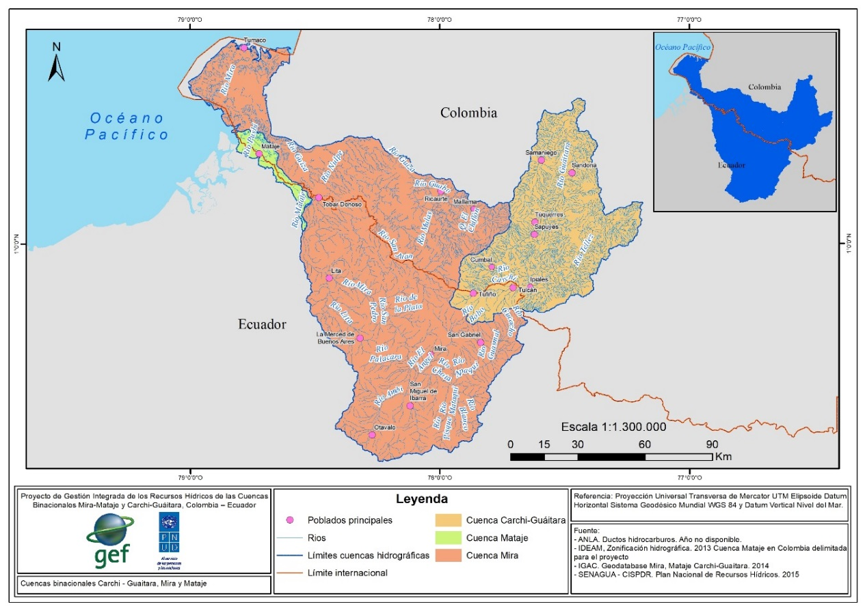
Figure 1. Transboundary rivers basins which drain into the Pacific Ocean: Mira (orange), Mataje (green) and Carchi – Guáitara (yellow).

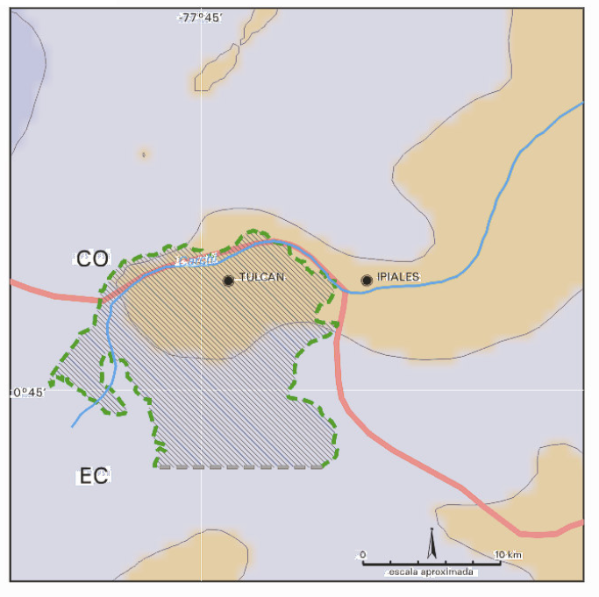
Figure 2. Approximate location, size and shape of the Tulcán – Ipiales transboundary aquifer (UNESCO, 2007).

- Colombia and Ecuador have made significant efforts to advance towards collaborative action, however the situation is complex and requires a more comprehensive approach. There are a number of evident symptoms of severe problems in several areas of the transboundary basins.
- Three major problems are evident: (i) biodiversity loss, (ii) deterioration of environmental services and (iii) decreased quality of life of the population (Figure 1).
- The three above mentioned major problems are caused mainly by anthropogenic causes. The situation is different on each basin, but in general, the main causes are:
- Inadequate management of solid waste and effluents that causes water and soil pollution and ultimately have impacts on human health and contribute to biodiversity loss.
- Poor farming practices that causes soil erosion and land degradation, deterioration of ecosystems that produce water (e.g., paramos) and regulate water flows, and pollution of water and soil.
- Land use change, mainly expansion of farming areas, that causes habitat fragmentation and destruction of native vegetation.
- Increased demand of water that contributes to conflicts among competing users.
- Illicit drug cultivation (coca in the lowlands and poppy in the highlands) and processing that has a range of consequences including deforestation, habitat degradation and fragmentation, water and soil pollution, and land degradation.
- Climate variability and climate change which exacerbate other pressures like the duration of dry periods and the survival of fauna and flora. Also, extreme weather events, mostly related to El Niño Southern Oscillation (ENSO), have become more intense and frequent.
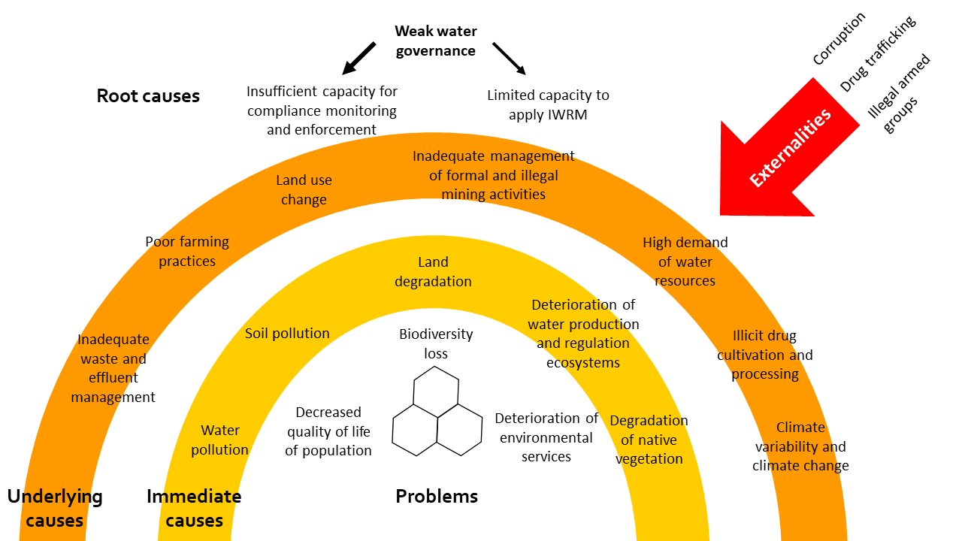
Figure 2. General causal chain analysis of the situation in the transboundary basins.

- Two root causes have been identified: (i) insufficient capacity for monitoring and enforcing compliance of pertinent regulations and (ii) limited capacity to apply comprehensive integrated water resources management (IWRM). Ultimately, these causes reveal weak water governance.
- The scenario is influenced by critical externalities. Illegal armed groups and drug cartels operate in the area. Their activities in turn generate widespread insecurity and crime, encourage illegal activities (e.g., coca cultivation and gold mining), and undermine the social fabric (Figure 1).
- This somehow coincide with the results presented by ILEC et al., (2016) who identified that (i) water quality (mainly wastewater pollution) and (ii) governance (mainly legal framework) had the highest risk. In Mataje, ILEC et al., (2016) also included a very high risk in wetland dysconnectivity. In Mira, ILEC et al., (2016) included high risk of hydropolitical tension (Figure 2).
- The transboundary basins have similar problems, but their conditions and severity of their issues are quite different.

Carchi - Guáitara
- Carchi – Guáitara has the highest population density (1.16 persons/ha) and the highest percentage of farming area. The impact of illegal activities is felt, but with less intensity than in the other basins.
- The main problems are degradation of natural ecosystems, water pollution, and limited availability of water during the dry season (Figure 3).
- Water pollution is caused by a range of sources, including farming, domestic sewage and gold mining in Colombia. This basin has a large surface dedicated to farming activities that in turn discharge large amounts of agrochemicals. A severe case is potato production in the Carchi province, where heavy use of pesticides has resulted in poisoning and neurological impairment of farmers (Cole et al., 2002; Yanggen et al., 2004; Sherwood, 2009).
- Degradation of paramos and native forests is a key issue which is mainly caused by expansion of the agricultural frontier and the common practice of burning paramos. Paramos have special protection status in both countries. In Colombia, mining and oil exploration and extraction are prohibited, and regional corporations must develop zoning and management schemes. Paramo areas must be delineated and sanctioned by the Ministry of Environment and Sustainable Development (MADS). The Ecuadorian constitution includes paramos among fragile and threatened ecosystems that have a special management regime. Paramos must have participatory management plans that consider their contribution to watershed dynamics. However, there are practical limitations to enforce regulations. A key matter is land access limitations faced by small farmers, who are forced to clear accessible natural areas.

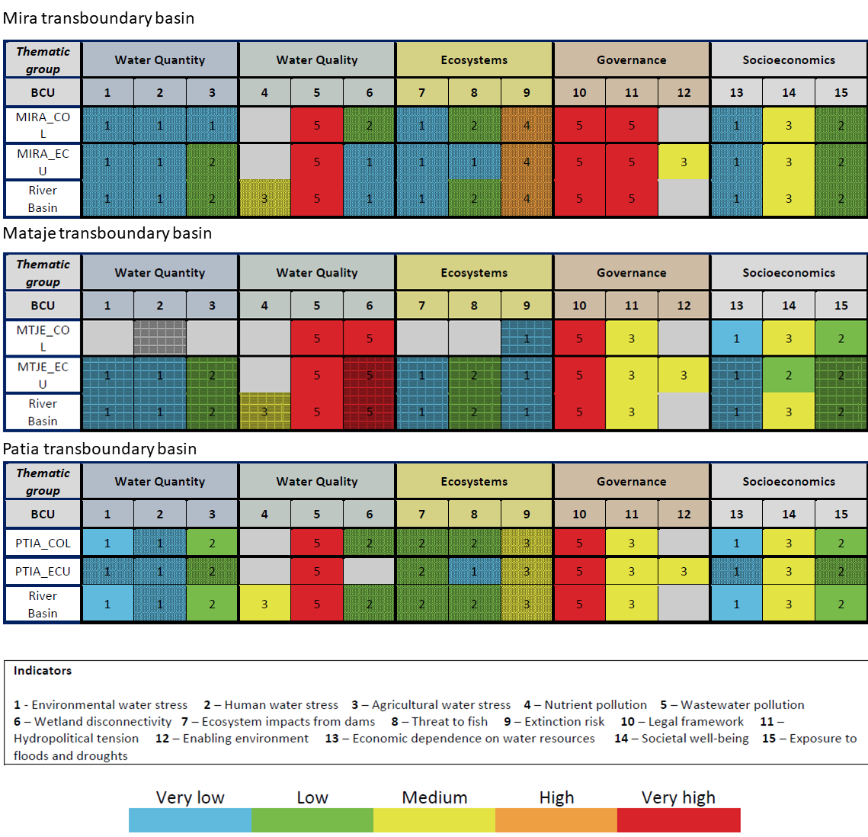
Figure 3. Risk levels of key indicators for Mira, Mataje and Patia transboundary basins from ILEC et al., (2016).

Mira
- Mira contain patches with dense population (mostly in Ecuador) and intense farming (mostly on the middle – high basin), but an overall lower population density (0.64 persons / ha). The impact of illegal activities is stronger than in Carchi – Guáitara. The Colombian side is affected by widespread coca plantations and attacks to civilians and infrastructure. But violence affects both sides of the border
- The upper and lower basin have different problems. In the former, water pollution, degradation of natural ecosystems and soil degradation are severe issues (Figure 4). Also, water scarcity has exacerbated in certain areas (e.g., Chota valley, Lita). Water pollution is caused by a range of sources, including farming, domestic sewage, effluents from various activities (e.g., dairy and panela production, illicit crops). Illegal gold mining occurs in several locations and have environmental and social impacts far beyond water pollution (UNODC, 2018a; Anon, 2018e; Bonilla, 2019).
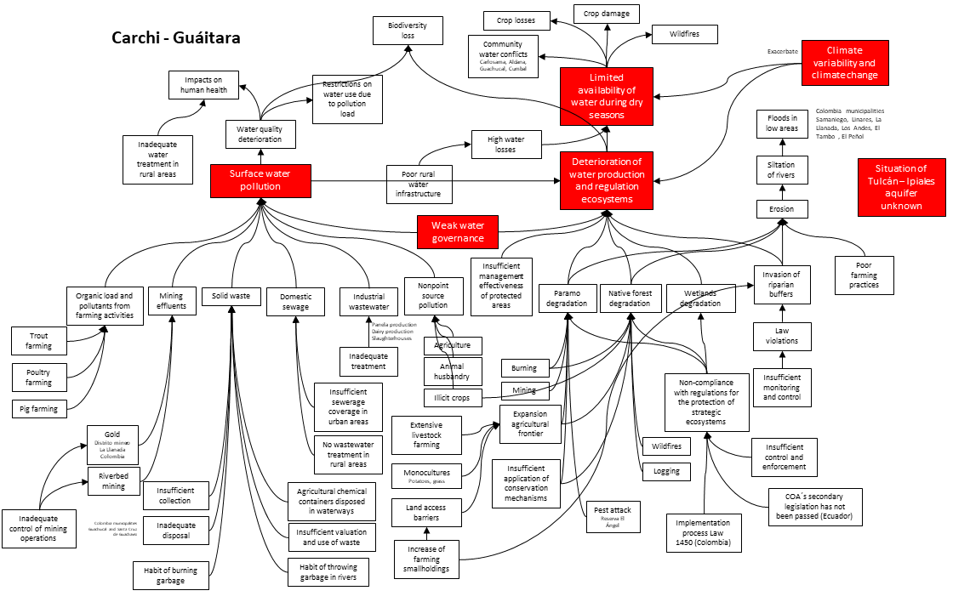
Figure 4. Causal – chain analysis of the situation in the Carchi – Guáitara transboundary basin.
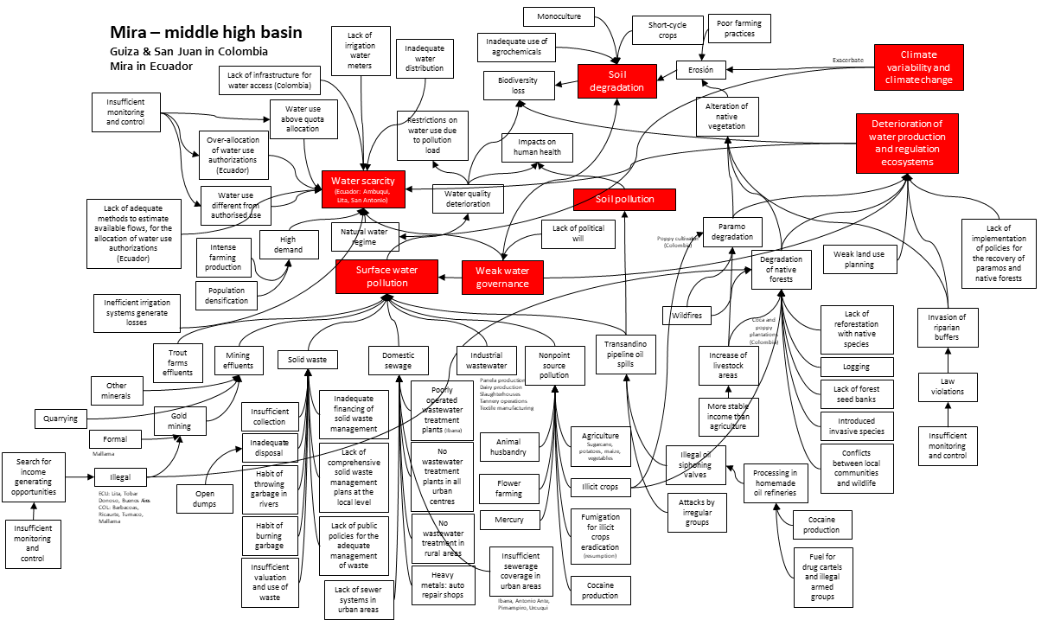
Figure 5. Causal – chain analysis of the situation in the upper Mira transboundary basin.

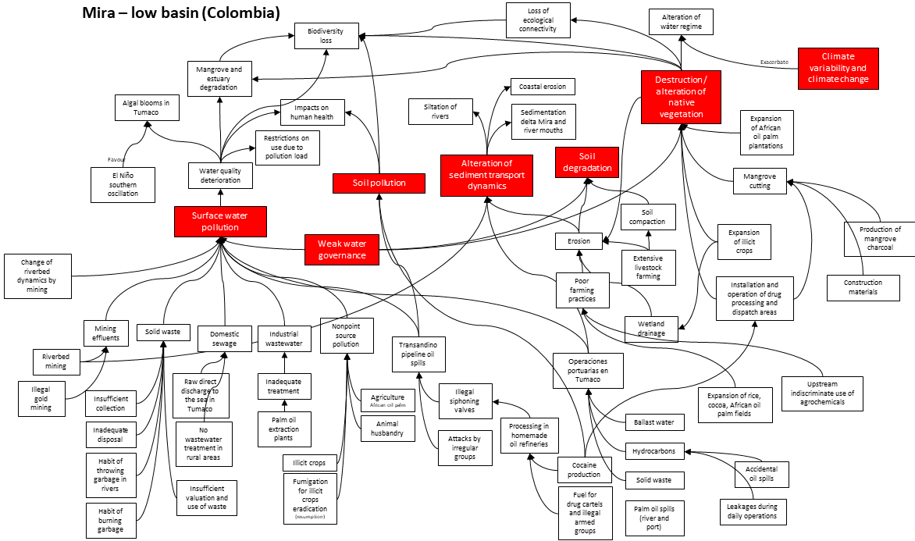
Figure 6. Causal – chain analysis of the situation in the lower Mira transboundary basin.
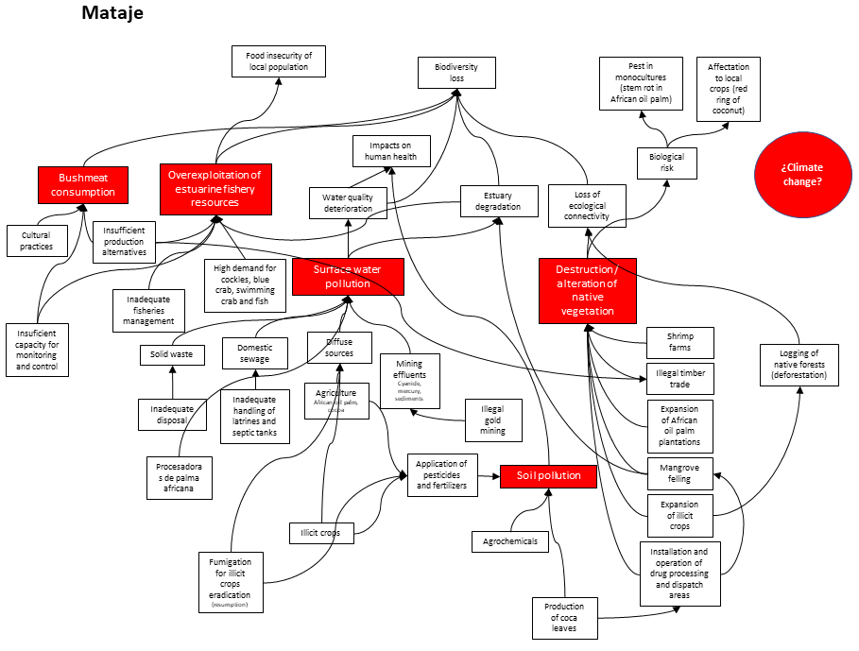
Figure 7. Causal – chain analysis of the situation in the Mataje transboundary basin.
- In the low basin, the cultivation and processing of coca and African oil palm are major drivers of degradation of natural ecosystems, water pollution and soil degradation (Figure 5). Hydrocarbon pollution is generated by sabotage of the Transandino pipeline, leakages from illegal siphoning valves and homemade oil refineries. Sediment dynamics in the river and the ocean discharge are also altered by the load of sediments released by erosion, riverbed mining, and illegal gold mining. On the mangroves of the river delta area a key issue is the reduction of abundance and size of piangua. Anadara tuberculosa is listed as "vulnerable" (main threat overexploitation) in Colombia´s red list of marine invertebrates (Ardila et al., 2002).
Mataje
- This basin has the lowest population density (0.18 persons/ha). About 47% of its surface is dedicated to agriculture, a main driver of land use change are African oil palm plantations. The impact of illegal activities is stronger than in the other two basins. In general, living conditions are harsh and human settlements are small and remote, with vert limited access. This facilitates the installation of illicit crops and drug processing facilities.
- The main problems are degradation of natural ecosystems, water and soil pollution, and overexploitation of estuarine fishery resources (Figure 6). There is also bushmeat consumption, but its severity is difficult to assess due to lack of information.
- The main causes of the degradation of natural ecosystems are land use change and deforestation. The main drivers of land use change over the years have been shrimp farms, African oil palm plantations and illicit crops. Similarly, water and soil pollution are caused primarily by effluents from agriculture, illicit crops and illegal gold mining.
- Overexploitation of fishery resources is crucial in the estuarine area. The high demand for piangua in Ecuador has caused overfishing in local areas in the Cayapas – Mataje estuarine system and induced increased exploitation in the neighbouring areas in Colombia. Despite existing regulations and several project interventions, the condition of the piangua population has not improved. Between 51% and 58% of pianguas sampled in San Lorenzo (Ecuador) between 2011 and 2014 were below minimum landing size (Moreno, 2017).

Climate variability and climate change
- In the transboundary basins the most obvious risk factor is ENSO, a recurrent planetary climate phenomenon. El Niño (ENSO´s warm phase) produces an extreme increase in rain and floods in Ecuador and a rain deficit and severe drought in Colombia. It is anticipated that climate change will produce stronger and more frequent ENSO events (Cai et al., 2014; Cai et al., 2015).
- During El Niño, the Cayapas - Mataje estuarine system is affected by high tides and strong swells. In the Ecuadorian lowlands of the project area, heavy rain causes river overflow and landslides on unstable hillsides. Similar conditions occur in the coastal plain of Colombia (Tumaco municipality). In the Nariño department, temperature increases, and the highlands experience a water deficit (range 40 - 80%) and extensive frosts which affect crops.
- La Niña (ENSO´s cold phase) produces the opposite. In Ecuador, a deficit of precipitation and increased rainfall in Colombia. However, the Colombian coastal lowland of the project area also has a reduction in precipitation (Cadena et al., 2004). Heavy rainfall affects mostly the highlands of Nariño department with severe impacts. For example, during La Niña 2010, 18,480 families were affected by floods and 10,996 by landslides (CEPAL, 2012).
- Extreme weather events, like floods and landslides, impact the local population in a range of ways like loss of agriculture production and household items, damage of infrastructure, and increased health risks. At the moment, both countries do not share the hydrometeorological data from the three transboundary basins.
- There is limited specific information about the possible impacts of climate change in the transboundary basins and the water cycle. However, Nariño´s adaptation plan project for 2050 an increase in temperature of about 2°C and an increase of 9% in precipitation in the lowlands (Guevara et al., 2016). Similarly, water supply to rivers is projected to increase between 50% and 100% in the coastal lowlands where Mira river discharges and between 27% and 50% on the rest of the lowlands. In the highlands, the projected increase of water supply to rivers is <25%. But, IDEAM et al., (2015) has different conclusions and projects an increase in precipitation three times higher than Guevara et al., (2016); with higher levels in the coastal fringe and the higher Andes.
- There is no similar information for Ecuador. But, Jimenez et al., (2012) made estimates for 2050 for Imbabura, Carchi and Esmeraldas provinces:
- an increase in temperature of 1.65 °C, 1.67 °C and 1.39°C, respectively in Imbabura, Carchi and Esmeraldas,
- a minimum reduction of -0.2% in precipitation in Imbabura, and
- an increase in precipitation in Carchi and Esmeraldas of 2.16% and 10.87%, respectively.

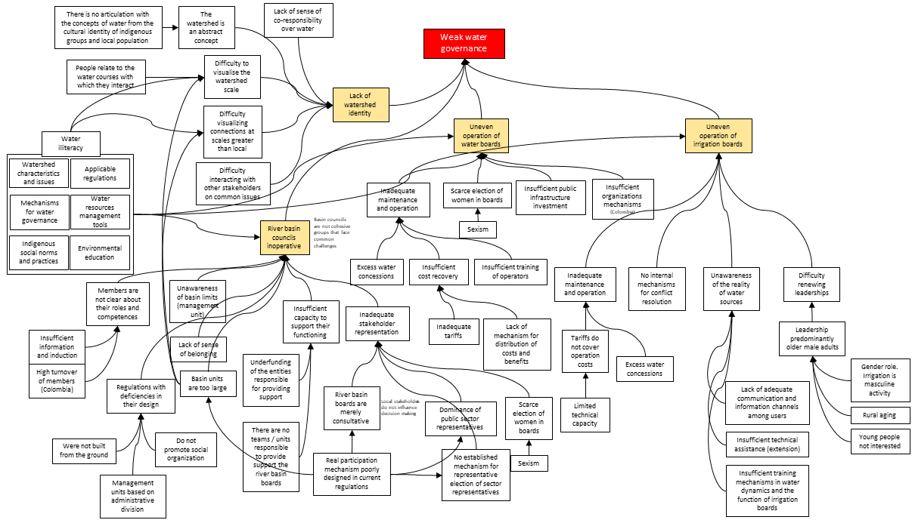
Figure 8. Causal – chain analysis of weak water governance in the transboundary basins.

Weak water governance
- The transboundary basins face a complex situation. A number of causes can be addressed with more (i) stringent monitoring and enforcement of existing regulations and (ii) investment in public infrastructure and development projects. But at the basis of the causal chain analysis is weak water governance. Good water governance is fundamental to implement IWRM because it must strive to balance conflicting interests over water resources and the present and future needs of the various user groups.
- Both countries have adopted and apply a watershed management approach and have long been advancing towards collaborative management. Even the idea of binational basin councils has been discussed. This is very positive, because sound IWRM of each transboundary basin will require a holistic perspective and actions from multi-level stakeholders, from water users up to water authorities. However, there are severe limitations to advance collaborative IWRM. The main causes are: (i) lack of watershed identity, (ii) existing river basin councils are inoperative, and (iii) uneven operation of water and irrigation boards (which are the fundamental units that exercise water resources management) (Figure 7).
- At the moment, local water stakeholders lack watershed identity. This occurs mainly because the “watershed” is an abstract technical concept that is difficult to visualise and grasp by local persons who normally know and relate to the water courses with which they interact.
- It has been shown that geographic scale is fundamental for the development of water management purpose (Cheng & Daniels, 2005; Cohen & Davidson, 2011; Cohen, 2012; Cohen, 2012a; Druschke, 2013). Existing management national units are too large and therefore users have difficulty in visualising clear relationships between watershed health and local conditions. Also, the watershed units and the management structures (e.g., water rights) do not relate to the cultural and spiritual significance of water to indigenous people.
- Existing basin councils (Mira and Carchi in Ecuador and Guiza in Colombia) are inoperative. River basin councils are merely consultative bodies where stakeholders do not influence decision-making. Councils are dominated by government representatives, that in practice decide the course of actions. Stakeholders do not have substantive representation, that is to act in the interest of the represented and to be accountable and responsive to them (Pitkin, 1972; Dovi, 2018). Stakeholder representation in river basin management is a complex matter that has not been deeply analysed (Wester et al., 2003; Wester, 2008; Carr, 2015; Franzén et a., 2015). The current approach in the project area is formalistic and does not promote empowerment of the various groups of water users (i.e, sharing power).
- Cohesion and representation in basin councils are key elements, because these bodies are crucial to construct watershed identity and connection between local users and the regional scale of watershed management (Cheng & Daniels, 2005; Reich, 2006). In contrast, rural water and irrigation boards are grassroots bodies that have direct action in water access and use. These are the basic units to construct water governance from the ground up to the basin level. However, there are some limitations to take in to account:
  - There is a large number of water and irrigation boards. It was not possible to obtain precise numbers. But, from available information it was found that on the 13 Ecuadorian municipalities that are part of the transboundary basins there are 112 water boards (source SENAGUA). Four Colombian municipalities (i.e., El Peñol, El Tambo, La Llanada and Los Andes) have 70 water boards (rural aqueducts) (source Nariño Government). With respect to irrigation boards, Carchi´s seven municipalities have 43 irrigation boards (source SENAGUA) and Ibarra´s six municipalities have at least 143 community irrigation systems (Prefectura de Imbabura, 2015).
  - Irrigation boards are absent in water abundant areas like the Mataje basin. This is an area with abundant water resources and a very small population, where most households use water directly from the watercourses.
  - There is great disparity in the operation and performance of water and irrigation boards. There are strong water and irrigation boards, but also groups that face serious difficulties. In general, local communities strongly assume their responsibility to administer water systems, but sustainability is a major concern. A shared issue is inadequate maintenance and operation of infrastructure and the related services (e.g., disinfection of drinking water) in which cost recovery is a common limitation. In addition, there are difficulties with (i) renovating leadership and (ii) women involvement.
  - The Awá and lowland Afro-descendants do not integrate formal water management entities. These groups have a profound cultural and spiritual linkages with water but live in forest areas with abundant water resources. Therefore, grassroots management entities like water and irrigation boards are not close to their everyday practice. Consequently, it is a challenge to engage these groups in water governance instances.
- During project preparation it was found that young persons, in general, are not interested or motivated to get involved in water governance instances. This might be related to the perception that other activities offer better social and economic conditions than agriculture. It has been common that smallholders motivate their children to study and move from farming. This is a key worldwide issue that has been analysed by several authors (Leavy & Hossain, 2014; FAO, 2014).
- Women have limited participation in water and irrigation boards. A situation that is more acute in irrigation boards. In general, there are marked gender roles assigned to men and women, where men run farming and irrigation and women are in charge of household chores and drinking water. Women face barriers to take leadership roles. In Ecuador, only 15% of water boards and 4% of irrigation boards of the project area were headed by women.

The baseline scenario and barriers that need to be addressed
- The transboundary basins are affected by degradation of vital water resources that in turn threaten biodiversity hotspots (tropical Andes and Tumbes-Choco-Magdalena) and the livelihoods of about 1.1 million persons (ca., 24% of them indigenous people). The current scenario is affected by (i) illegal activities that contribute to biodiversity degradation, security risks for the local population, and deterioration of the social fabric, and (ii) climate change which may result in stronger and more frequent ENSO events and an overall increase in temperature and precipitation.
- To mainstream IWRM at the national and transboundary levels requires coordinated and synergistic action including multiple actors with specific mandates and responsibilities. However, water governance is weak. Therefore, to advance towards collaborative transboundary water management it is necessary to strengthen bottom-up water governance and to mainstream reforms to build collaborative IWRM.
- Addressing the issues in the three transboundary basins will require interventions at several public and private levels that are beyond the scope of this project. Currently, local and central governments and civil society are investing in actions that contribute to solve the problems (e.g., irrigation infrastructure, motivating binational collaboration, fighting organised crime), but it is unlikely to have profound short-term impacts because of the complex scenario.
- In this context, this project will contribute to promote the conservation and sustainable use of water resources by mobilising local, national and binational actions for a comprehensive intervention that strengthen water governance as a basis for IWRM. The Transboundary Diagnostic Analysis / Strategic Action Programme process (TDA / SAP) will be used to build the foundation for long-term collaborative action.
- Not incorporating a holistic approach to catalyse synergic actions in the transboundary basins will result in further degradation of the water system and loss of valuable biodiversity and ecosystem functions.
- Even though both countries have solid bilateral cooperation and are committed to address the problems of the transboundary basins, there are barriers which limit the application of IWRM in the transboundary basins.
Barrier 1. Limited experience applying IWRM in transboundary basins
- Colombia and Ecuador have made important advances and have increased experience in water resources management at the national level. IWRM, watershed management and the ecosystem approach are embedded into the national regulations and strategies of both countries. However, the application of IWRM in the transboundary context is still a new idea. There is previous experience to build upon. Both countries participated in the preparation of the Strategic Action Programme for the Amazon basin, and Ecuador is working with Peru on the preparation of an SAP for three transboundary basins. However, the existing limitations for good water governance make it difficult to move up from domestic to binational water governance.
- In both countries, it is necessary to develop capacities in water diplomacy (also called hydro-diplomacy) to address possible disagreements and conflicts over water-related matters. This is crucial since the Colombia – Ecuador border is a very sensitive area. In addition, it is necessary to train technical staff from the national water authorities and local governments in integrated watershed management and multilevel dialogue in order to build social sustainability for water management.
Barrier 2. Insufficient intersectoral coordination for water resources management
- Despite the existing national policies and institutional arrangements for water resources management, intersectoral coordination is still an ongoing challenge. In Colombia the national water policy (MAVDT, 2010) identifies the need to strengthen collaboration among the various entities that have an impact on the management of water resources. A key development has been the creation of the National Water Council to increase coordination of sectoral policies, plans and programmes within the framework of the national water policy. At the local level it is still challenging the coordination with the regional environmental authorities, local governments and community water aqueducts. There is a similar challenge in Ecuador, where the water authority must coordinate with other sectoral entities (e.g., Ministry of Agriculture and Livestock), municipalities (responsible for drinking water and sanitation), provincial governments (manage public irrigation systems and develop infrastructure in water basins) and community organisations that manage water provision and irrigation services. The Ecuadorian water law established the Intercultural and Plurinational Water Council to oversee the implementation of public policies, but this entity has not yet functioned.
Barrier 3. Limited integration of key stakeholders in managing water resources
- Despite the existing legal and institutional developments, there is incipient participatory management of water resources in the target basins. As mentioned before, stakeholders do not have substantive representation in basin councils. Lack of coordination among stakeholders – which have different perspectives and usually competing water needs -- has contributed to predominate sectoral and local perspectives that do not envision the watershed as a whole.
Barrier 4. Hydrometeorological data of the transboundary basins is not shared
- Transboundary data sharing is a necessary element for IWRM and early warning systems for disaster risk reduction. Currently, the National Institute of Meteorology and Hydrology (INAMHI) and the Institute of Hydrology, Meteorology and Environmental Studies (IDEAM) do not share hydrometeorological data of the transboundary basins. There are two main limitations:
  - Data generation. The World Meteorological Organization (WMO) recommended meteorological station density is not met. Ecuador´s station density is insufficient in Carchi - Guáitara, upper and lower Mira and Mataje. Colombia´s station density is insufficient in upper Mira. For hydrological monitoring, station density is insufficient in the Ecuadorian part of Mira, and no country has monitoring stations in Mataje.
  - Data sharing. There are no agreed data sharing procedures.
Barrier 5. Existing binational instruments are insufficient to sustain collaborative action
- Colombia and Ecuador have a long history of binational collaboration, several instruments have been developed:
  - Colombo - Ecuadorian Neighbourhood and Integration Commission, which has been the basis for several initiatives and agreements. It has a Binational Technical Committee on Environmental Affairs which has a watershed working group.
  - Colombo - Ecuadorian Integration Zone to foster sustainable development on the border area. A binational plan for the integration zone was adopted in 2014 (DNP & SENPLADES, 2017); it has a set of sectoral targets and an investment plan. A fiduciary fund -- Fondo de Desarrollo Fronterizo y de Reparación Social-- was created in 2018 to finance actions from the binational plan.
  - Binational cabinets. This is an operation mechanism to define and agree joint actions on issues of bilateral interest, as well as to assess progress of previous commitments. Seven binational cabinets have been held since 2012. On the sixth binational cabinet (Pereira, February 2018) both presidents endorsed the present project.
  - Binational plan for integrated water management for the three transboundary basins (MINAMBIENTE & SENAGUA. 2017). This plan was prepared by Colombia´s Ministry of Environment and Sustainable Development (MADS) and Ecuador´s Water Secretariat (SENAGUA) within the framework of the watersheds working group and was endorsed by the governments on the fourth binational cabinet (Cali, December 2015). The agreed action plan established that at least one project must be prioritised to be executed depending on budget availability of the countries.
- Despite all this progress, there are limitations to sustain formal binational action to advance on transboundary watershed management:
  - First, the binational plan for the integration zone includes within the environmental binational policies to guarantee integrated watershed management with emphasis on the basins that occupy binational territory. But there are no specific related actions. The indicators and targets for environmental sustainability relate to cover of native forest.
  - Second, the binational plan for the transboundary basins (MINAMBIENTE & SENAGUA. 2017) is very general and is not being implemented.
- Ecuador and Peru signed in 2018 an international instrument that established a binational commission for integrated management of water resources of the transboundary watersheds. A comparable formal instrument could be used to sustain the work on the transboundary watersheds shared by Colombia and Ecuador.
Barrier 6. Deterioration of the social fabric as a result of illegal activities
- As mentioned before, the transboundary basins are affected by illegal actions that cause insecurity and violation of human rights (HRW, 2018). Key issues are the fragmentation and expansion of illegal armed groups, increase of illegal crops in Colombia and illegal mining in both countries, attacks to civilians and forced displacement. Illegal activities have fostered an illegal economy based on cross-border trafficking of drugs, arms, ammunition, supplies, among others. Widespread violence and illegal activities deteriorate the social fabric and undermine social cohesion.
- The construction of water governance for transboundary watershed management will have to confront a complex scenario and therefore implement conflict-sensitive actions that do not have adverse effects on the stakeholders and the overall context.
Alternative scenario and project strategy
- Solving the range of problems occurring in the three transboundary watersheds is beyond the means of the present project considering the scope of interventions which will be needed, such as (i) investing in facilities for wastewater treatment and irrigation, (ii) strengthening control and enforcement of productive activities or (iii) confronting illegal mining. However, the present GEF project can assist the countries to set the foundation for collaborative transboundary watershed management.

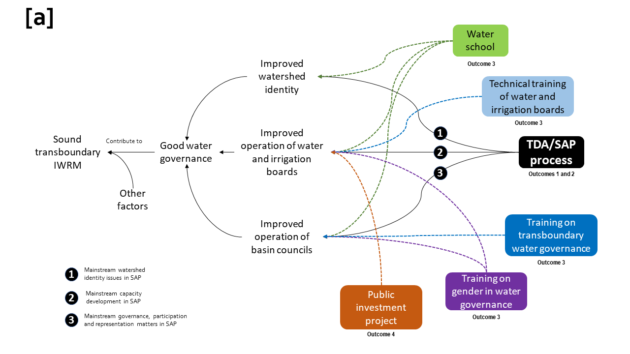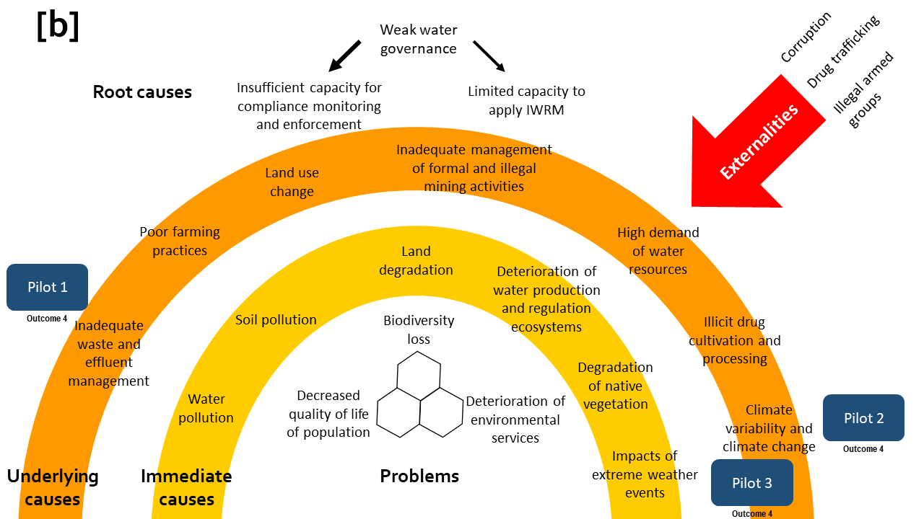
Figure 9. Theory of change (a) and points of entry of the three pilot interventions.

- The project will focus on water governance which is one of the root causes of the present situation in the area (Figure 1 and Figure 7). This is done in the understanding that improved water governance will contribute to construct sound transboundary IWRM (Figure 16). As mentioned before, there is a range of other factors that limit IWRM, but the basis of this project is that improved water governance will catalyse a range of improvements along the causal chain.
- The TDA/SAP process will be the main tool. An exercise of deep collaborative and inclusive analysis and strategic planning will warrant the mainstreaming of fundamental elements such as watershed identity, governance, participation and representation. The aim will be to have a formal binding instrument (the SAP) that has an adequate balance between the technical, social-gender and political dimensions of transboundary management. In addition, it is envisioned that the SAP will be the basis for future actions at the local, national and binational levels.
- To complement the TDA/SAP process, the project will develop:
  - some training activities to confront (i) the lack of watershed identity, (ii) the issues in the operation of river basin councils and water and irrigation boards, and (iii) the limited participation of women in water governance (Figure 8a), and
  - some practical experiences to generate learning on key issues (inadequate wastewater treatment, climate-related landslides, and hydrometeorological data sharing) (Figure 8b), and
  - the preparation of a public investment project to obtain fiscal funds for improving the performance of rural aqueducts in 12 municipalities of Nariño.

Project components and expected outcomes
- The objective of the project is to promote integrated water resources management (IWRM) in the Mira, Mataje and Carchi-Guáitara river basins shared by Colombia and Ecuador by strengthening the institutional and managerial capacities at the regional, local and community levels for achieving environmental and socioeconomic benefits.
- The project is organized in four components and five outcomes. In total, six outputs will be generated (Table 1). The four components are:
- Component 1 will develop a participatory process to generate an integrated diagnosis on the current situation of the three transboundary basins (i.e., Transboundary Diagnostic Analysis).
- Component 2 will develop a participatory process to prepare a binding instrument with priority actions to advance IWRM (i.e., Strategic Action Programme).
- Component 3 will help to build human capital through training activities.
- Component 4 will focus on generating and sharing lessons and practical experience.

Table 1. Project outcomes and outputs.
Outcomes | Outputs
Outcome 1. Priority transboundary issues affecting quality and quantity of water, its vulnerability to climate change and variability and barriers for IWRM, and their immediate and root causes, have been identified, including a governance and stakeholder analysis to further inform the SAP process. | 1. Transboundary Diagnostic Analysis (TDA) on Mira, Mataje and Carchi-Guáitara basins, based on the secondary information and generation of primary information, including structural causes, future status and dynamics completed and validated.
Outcome 2. Priority actions required for achieving IWRM of the Mira, Mataje and Carchi-Guáitara basins identified and integrated to the binational, national and sub-national development plans in both countries. | 2. Strategic Action Program (SAP) adopted by the two countries focused on priority actions (e.g., governance reforms, investments) to address the transboundary issues identified by the TDA.
Outcome 3. Improved individual and institutional capacities in both countries to apply IWRM in the binational basins. | 3. Training of key national and subnational stakeholders in key aspects to apply IWRM (water governance and improved operation of water and irrigation boards).
Outcome 4.1. Integrated water resource management and sustainable land use reduce pollution, improve water use efficiency and protect/restore aquatic ecosystems in the Mira, Mataje and Carchi-Guáitara river basins and their aquifers. | 4.1.1. Three small scale innovative interventions on IWRM to reduce pollution from domestic wastewater, facilitate hydrometeorological data sharing and reduce risk of climate-related landslides.  4.1.2. One pre-feasibility study to catalyse investments to improve the operation of rural water boards.
Outcome 4.2. Learning generated through replicable innovative interventions supports the SAP development and decision making. | 4.2. Systematization of results, lessons and experience from the project and the innovative interventions in the Mira, Mataje and Carchi-Guáitara basins is available for relevant national and subnational stakeholders, as well as for other projects through participation in IW: LEARN.

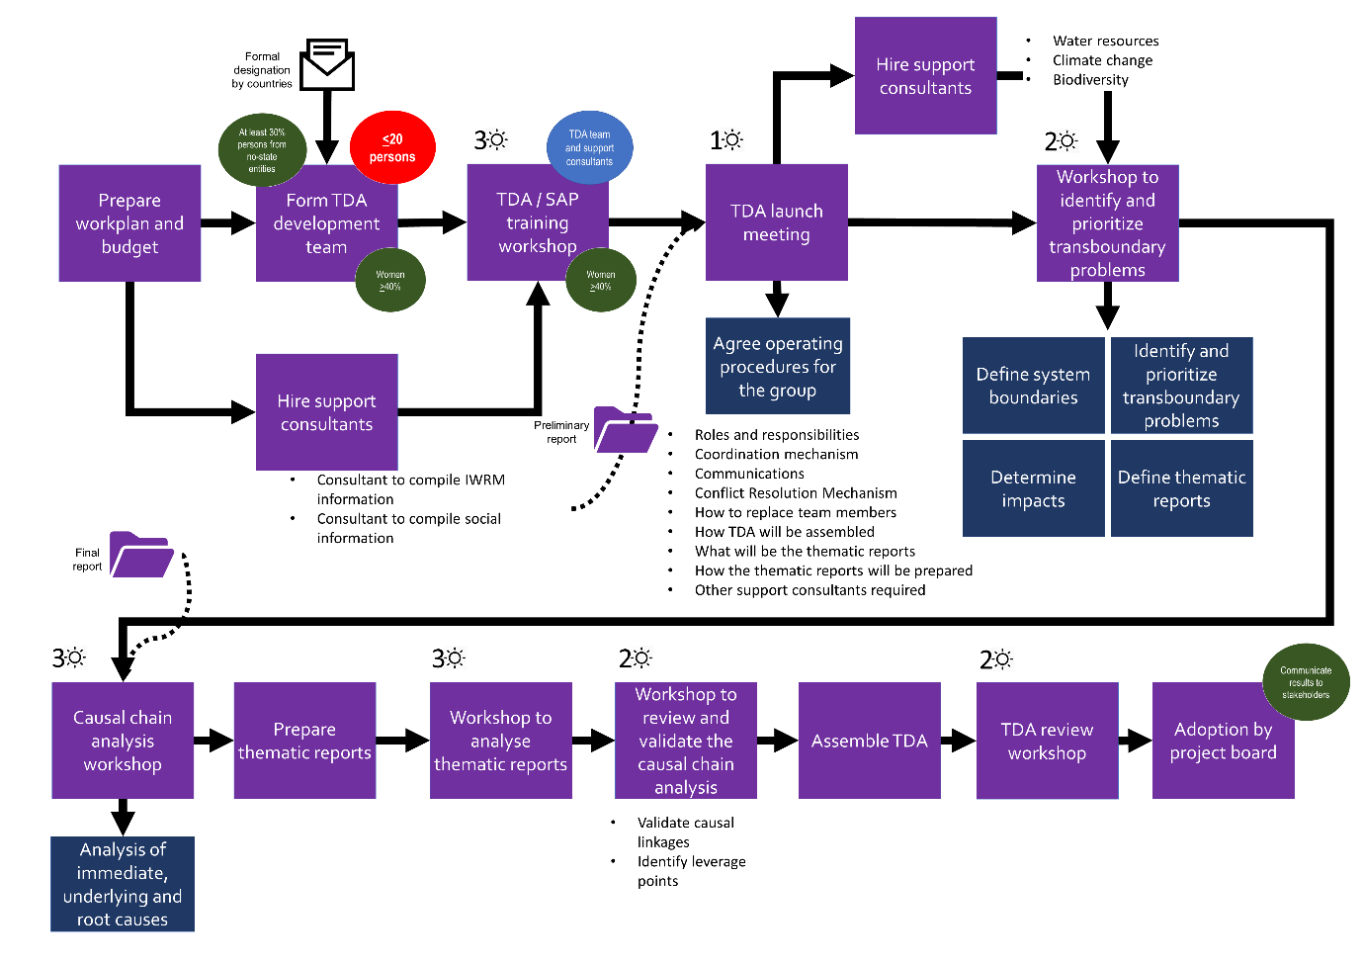
Figure 10. Road map for the development of the Transboundary Diagnostic Analysis.
Component 1. Generation of knowledge, information management and diagnostic analysis of the current status of the transboundary water resources (surface and ground waters) of the Mira, Mataje and Carchi-Guáitara binational basins.
Outcome 1. Priority transboundary issues affecting quality and quantity of water, its vulnerability to climate change and variability and barriers for IWRM, and their immediate and root causes, have been identified, including a governance and stakeholder analysis to further inform the SAP process.
- This is a binational component focused on completing a comprehensive analysis of the situation in the three transboundary basins. The expected outcome is that the situation of the watersheds is examined, and the transboundary and shared problems are identified (Table 10).
- This component will be driven by the binational coordinator of the project (CBP) in close collaboration with (i) a TDA/SAP specialist (ETS) and (ii) a gender, participation and intercultural specialist (EGP) (Figure 20). The ETS will be responsible for the technical implementation of the TDA/SAP process and the EGP will ensure that (i) the process is participatory and inclusive and (ii) that key aspects like governance, watershed identity, participation, representation and gender are addressed.
- The construction of the Transboundary Diagnostic Analysis will be based mainly on existing information. There is good amount of material that has been generated over the years by a range of entities. For example, (i) there is hydrometeorological and water quality information generated by INAMHI and IDEAM, (ii) there are lessons about women involvement in water conservation and local measures for climate change adaptation that have been developed by Altropico, Corporación Grupo Randi and WWF-Colombia, and (iii) there are lessons about water conservation that have been generated by the Government of Nariño (GOBNAR) and the three provincial governments of Ecuador. In addition, there are some ongoing projects that will produce valuable inputs for the TDA. Finally, both countries will bring their previous experience with the preparation of the TDA for the Amazon basin (GEF ID 2364) and the Ecuadorian experience with the TDA of the Puyango-Tumbes, Catamayo-Chira and Zarumilla basins (GEF ID 5284). A strategic axis of the analysis will be the linkages between watershed (upstream) and coastal (downstream) dynamics (e.g., pollution, sediment transport, fisheries and coastal biodiversity).
- The standard GEF methodology will be used to develop the TDA/SAP process (GEF, 2013). However, the TDA process was adapted during project preparation (Figure 9). The main adaptations are:
- Set a minimum level of participation of persons from non-state entities (>30%) and women (>40%) in the TDA development team.
- Have consultants that compile and systematise information before the first meeting of the TDA team.
- Dedicate the TDA launch meeting to agree on the operating procedures of the group.
- Have a specific workshop for the identification of prioritization of transboundary problems.
- Have a specific workshop (after thematic reports have been prepared and analysed) to review the initial causal chain analysis and identify the leverage points.
- Four thematic reports were identified during project preparation:
- Thematic report 1. Governance of water and irrigation boards with a gender approach and intercultural analysis.
- Thematic report 2. Diagnosis and prospective of supply, demand, water balance and water quality in the transboundary basins Ecuador-Colombia.
- Thematic report 3. Assessment of vulnerability to contamination of the Tulcán Ipiales aquifer.
- Thematic report 4. Identification of innovative domestic water supply technologies applicable in rural areas of the transboundary basins.
- The TDA will be adopted by the project board and widely disseminated.

Component 2. Strategic planning to strengthen governance for transboundary IWRM in Mira, Mataje and Carchi-Guáitara binational watersheds and aquifers.
Outcome 2. Priority actions required for achieving IWRM of the Mira, Mataje and Carchi-Guáitara basins identified and integrated to the binational, national and sub-national development plans in both countries.
- A core group will be established to prepare the Strategic Action Programme (i.e., SAP development team). This group will be formed by key government agencies and the local governments that form part of the transboundary basins (i.e., GOBNAR, GAD Carchi, GAD Imbabura, and GAD Esmeraldas). The ministries of foreign affairs will have a fundamental role to facilitate bilateral negotiations and outlining the pertinent diplomatic procedures and instruments. It has been set a minimum level of participation for women (>40%) in the SAP development team.
- The SAP process was adapted during project preparation (Figure 10). The main adaptations are:
- To have consultants that implement a set of communication and consultation actions to ensure that SAP development is inclusive.
- Dedicate the SAP launch meeting to agree on the operating procedures of the group.
- To have two moments for consultation. The first with local stakeholders, and the second with key government entities (e.g., ministries of the economy, cabinet council).
- The EGP will ensure that the process is participatory and inclusive. For this purpose, a set of actions will be implemented to ensure fluid information, dialogue and consultation with stakeholders and indigenous people and Afro-descendants (from source-to-sea approach). An SAP participation and gender equality assistant and five community workers will be contracted to work at the local level.
- The information, involvement and consultation process will initiate when the TDA is adopted by the project board (Figure 10). The first step will be to communicate its content (e.g., transboundary problems and root causes). Afterwards direct dialogue will continue to analyse key topics (e.g., forms for effective representation in basin councils, women empowerment) and generate contributions for the SAP development process. This will prepare the ground for formal stakeholder consultation of the draft SAP. Finally, this process will close when the SAP is endorsed by both government and its content is communicated to local groups.
- Prior consultation to indigenous people is mandatory in Colombia and the process to be followed has been clearly regulated. One of the aspects that is subject to consultation is national and regional development plans which may affect them directly (DNP, 2012). Because the SAP is an instrument that will include territories of indigenous people and Afro-descendants, it is very likely that it will have to subject to prior consultation before it is subscribed by the Colombian government. The information, involvement and consultation process which is part of the TDA/SAP process was designed to inform and engage indigenous people and their organisations so that, if prior consultation of the SAP is required, they will be well acquainted and have contributed to its construction.
- Once a first rough draft of the SAP is ready, it will be subject to stakeholder consultation in four geographic areas: Carchi – Guáitara basin, mid and high Mira basin, low Mira basin and Mataje basin (Figure 18). Three consultation workshops will be held on each area. The first, will serve to provide basic information, relevant background and to present the draft SAP. The following two workshops will provide space for analysis of the proposal and to draft comments, recommendations and contributions. A professional facilitation team will run the stakeholder consultation in close coordination with the community workers, the SAP participation and gender equality assistant and the EGP. The workshops will be designed to facilitate participation of women and men, mutual respect and collective decision-making.
- The inputs from stakeholder consultation will serve to assemble the SAP. This document will be subject to consultation with high level government officials from both countries (e.g., ministry of the economy, governor of Nariño, prefects of Carchi, Imbabura and Esmeraldas). This will serve (i) to build political support, (ii) to ensure that the SAP is linked to national priorities, (iii) to secure firm commitments in support of SAP implementation, and (iv) to finalise binational negotiations that might be necessary.
- Finally, the SAP will be formally endorsed at the highest possible level and widely communicated.

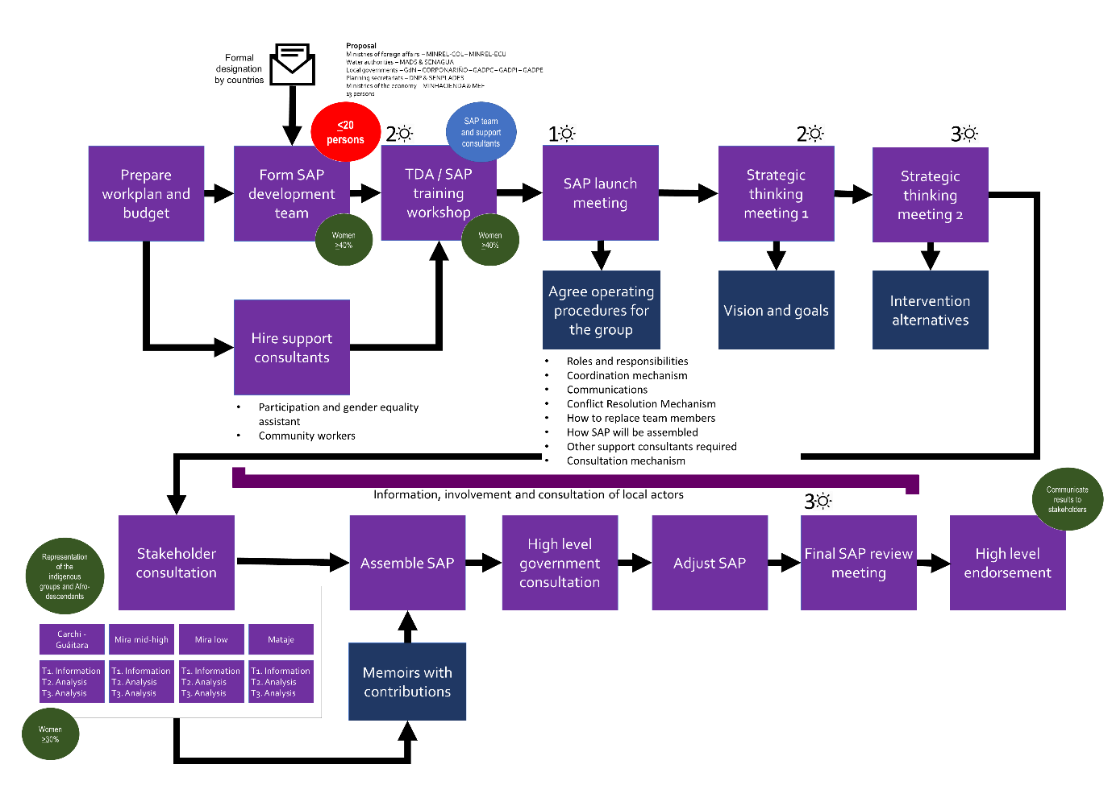
Figure 11. Road map for the development of the Strategic Action Programme.

Component 3. Capacity building at public, private and community level enabling the shared IWRM of Mira, Mataje and Carchi-Guáitara river basins.
Outcome 3. Improved individual and institutional capacities in both countries to apply IWRM in the binational basins.
- The expected outcome is Improved individual and institutional capacities in both countries to apply IWRM in the binational basins. There will be four sets of training activities aimed at different target groups:
  - A training course on transboundary water governance (hydro-diplomacy) will be designed for officers of national (e.g., water authorities, ministries of foreign affairs) and local governments (GOBNAR, prefectures). A set of short videos summarizing the main concepts and tools will be prepared and released through the project YouTube channel, IW: LEARN, and water authorities in both countries.
  - Water School, aimed at actors linked to IWRM, will be potentiated. The Water School is a continuing education programme established by SENAGUA in 2016. Since then the conceptual framework of the programme and some courses have been developed. The project will support an upgrading of the existing programme to ensure that is focused, effective and has impact, as well as mainstreaming a source-to-sea approach. Pilot courses will be developed and tested; the focus will be on basin councils and water and irrigation boards to contribute to strengthen water governance. A set of short videos with key messages will be prepared and disseminated. Lessons will be shared with Colombian partners.
  - Technical training for water and irrigation boards. There are several courses available in various organizations like the Colombian “Servicio Nacional de Aprendizaje” (National Training Service, abbreviated SENA). The project will consult with UNDP´s Cap-Net programme (www.cap-net.org) to take advantage of the large catalogue of IWRM and water management courses and its relevant networks in South America. The project will contribute to develop / adapt courses that mainstream elements to strengthen water governance. Using inputs from the thematic report 1 (paragraph 62) and the needs assessment prepared for the Water School, two courses will be prepared (one for water boards and the other for irrigation boards) and trainers will be prepared. The courses will be tested with specific groups in Colombia and Ecuador and adjusted afterwards as needed. Finally, institutional and financial arrangements will be prepared to anchor this type of training into local entities that can sustain them in the long term.
  - Training to mainstream gender in water governance. Based on the results of thematic report 1, a short training course will be prepared to promote participation of women in water governance (focused on the role of women in water and irrigation boards). The course contents will include gender and intercultural matters. The course will be developed and tested with specific groups in Colombia and Ecuador and adjusted afterwards as needed. It is envisioned that this course will be assimilated by local entities that can sustain it in the long term.
Component 4. Innovative interventions for testing the socio-economic and environmental benefits from applying the IWRM at selected sites of the Mira, Mataje and Carchi-Guáitara river basins.
- This component has two outcomes, the first is aimed at generating experience and lessons on key issues of the transboundary basins, and the second is intended at capturing and disseminating the project results, lessons and experience (Table 1).
Outcome 4.1. Integrated water resource management and sustainable land use reduce pollution, improve water use efficiency and protect/restore aquatic ecosystems in the Mira, Mataje and Carchi-Guáitara river basins and their aquifers
- This outcome comprises three small scale innovate interventions (output 4.1.1) and one pre-feasibility study (output 4.1.2). The three interventions are:
- Pilot 1. Implementation of purification systems using redworms (Eisenia foetida), as an alternative for the reduction of pollutant loads of residual domestic effluents in the rural parishes of Tufiño, Angochagua and Mataje in Ecuador, and the Municipality of Cumbal in Colombia.
- Pilot 2. Binational information system integration through strengthening of the hydrometeorological network at Carchi-Guáitara and Mira binational basins.
- Pilot 3. Community bioengineering as a process of adaptation to changing climate conditions and reduction of risk in the sub-basin of the Güiza River, Nariño, Colombia.
- The pilot interventions were identified and selected by the project partners and then prepared by the entities that will implement them once the project begins. Annex 11 of the PRODOC contain the pilot projects.
- Pilot 1 is a binational intervention to install vermifilters to treat domestic wastewater in three localities in Ecuador and one locality in Colombia. Vermifiltration is a low cost easy to operate procedure that removes organic matter and pathogens, the effluent can be used for irrigation and generate humus as a byproduct (Arora et al., 2014; Jiang et al., 2016; Singh et al., 2017; Jatin, 2018). Vermifilters are operating in a few localities in Ecuador and the pilot will contribute to have practical experience on their performance and operation and to assess their usefulness for small communities in the transboundary watersheds. For each locality, the project will cover part of the cost of the equipment the rest will be covered by contributions from local governments. This pilot will be executed by the Commonwealth of northern Ecuador (MNE) and by the Government of Nariño.
- Pilot 2 is also a binational intervention to have real-time hydrometeorological data available to support early warning systems and as an input for decision-making through a public binational integrated display (viewer) to query data at various scales. GEF funds will be used (i) to provide a few key equipment (e.g., automatic hydrological and meteorological stations, Acoustic Doppler Current Profiler), (ii) to develop capacities for data transmission, storage and treatment, and (iii) to present information through Colombia’s FEWS platform. The pilot will work in Carchi-Guáitara and Mira; Mataje was not included because of high risk for personnel and equipment. INAMHI and IDEAM will jointly execute this intervention.
- Pilot 3 is a national intervention in Colombia to demonstrate the use of native vegetation and local knowledge to stabilize unstable slopes. The pilot will be developed in the Ricaurte municipality (on an area with high risk of landslides) which is part of Guiza river basin (Mira basin). GEF resources will fund (i) the training of the local community, (ii) materials and plants, and (iii) documentation and dissemination of lessons. The pilot will be executed by WWF-Colombia in collaboration with GOBNAR.
- GEF funds will support a pre-feasibility study to improve performance of rural community aqueducts in 12 municipalities of the Nariño department. This study will (i) assess key operation issues (e.g., legal, administrative, financial, technical, maintenance) and the associated risks for human health, (ii) develop an action plan to overcome existing problems and strengthen operation of the aqueducts, and (iii) prepare a public investment project to implement the action plan. The action plan will include technical aspects (e.g., cost-recovery), governance and investments for maintenance and upgrade of the water system (e.g., grit chamber, distribution network). The information from the diagnosis and the action plan will directly feed to the TDA/SAP process. The public investment project will be in presented to the Colombian General System of Royalty Payments. It is foreseen that contribution of the GEF (USD120,000) will leverage an investment of > USD2,000,000 and will benefit about 82,000 persons. In addition, this financial mechanism will be discussed during SAP preparation.
- The project´s monitoring and evaluation specialist (EME) will monitor and document the implementation of the pilots and the preparation of the public investment project (a web-based logbook will be kept). This person will ensure divulgation of progress and results and will encourage networking among participants and key stakeholders.
Outcome 4.2. Learning generated through replicable innovative interventions supports the SAP development and decision making.
- This outcome focuses on documenting and sharing the lessons from the project and the pilot interventions. Three lines of work will be developed:
  - Facilitate communication among key actors of the project and disseminate achievements and lessons.
  - Document and disseminate the project lessons.
  - Incorporate the gender perspective in the project management and actions.
- At least 1% of GEF financing will support IW:LEARN activities such as setting and hosting a project website (see paragraph 87 and budget notes 25 and 27), share project achievements and lessons (see section document and disseminate project lessons) and support participation in relevant events and international waters conferences (IWC) (see paragraph 96).
- The project´s communication specialist (COM) will oversee this outcome.
Facilitate communication
- At project start, the COM will establish a workgroup with the communication teams of the project partners. Each partner entity will designate a delegate that will integrate the workgroup and that will be the channel for the flow of information and communication materials. This workgroup in communication will prepare and agree:
- Annual work plans that will be jointly implemented and evaluated, and
- protocols and procedures for collaboration and joint actions.
- The COM will prepare press materials and news, but their dissemination will be done through the channels and social networks of the project partners (e.g., YouTube, Instagram, Twitter).
- In the first quarter of project implementation, the COM will prepare:
- A detailed communications strategy that will be focused on (i) actors and groups of interest (with a clear focus on assisting the TDA/SAP process), and (ii) pilot intervention sites. The strategy will be analysed with the communication teams and it will be executed through annual joint work plans. At the end of each year, the workgroup will evaluate achievements and performance of the project´s communication strategy and it will make relevant adjustments.
- Three guidelines about:
a. Organization of sustainable events (UNEP, 2009; UNEP, 2012),
b. Behaviour and use of inclusive language with gender perspective, and
c. Organization of inclusive events with gender perspective.
The guidelines will be agreed with the partners and implemented in all project actions.
- The EPCG will be responsible for managing the project website that will be linked to the websites of the project partners, UNDP and IW: LEARN.
- If necessary, accounts will be created and maintained in virtual platforms and social networks (e.g., Facebook, Twitter, YouTube, Instagram) that are accessible to the target audiences of the project. However, the priority will be that information flows through the partner channels and networks.
- A quarterly digital bulletin with news and information of the project will be prepared, which will be distributed to all the target audiences of the project.
Document and disseminate project lessons
- The COM will establish both methods and procedures for the project team to systematically document the experience of the project and finally prepare documents that present the project learning. The COM will guide in the practice the project team so that they can adequately document experiences, good practices and the interventions performed.
- Onsite meetings for self-assessment and reflection with be organised with local key stakeholders implementing pilot interventions. A key element of these sessions will be to examine women´s contributions and perspectives. The results of these meetings will be systematized and presented to the Steering Committee of the project and reported in the annual reports to the GEF.
- At the end of year 3, it is expected to prepare three documents that systematise the project experience:
- Application of the TDA / SAP process in the three transboundary watersheds.
- Advancing governance in the transboundary watersheds.
- Visibility and strengthening of the role of women in water management.
- These documents will have a dissemination format to be accessible to a broad audience. Each document (i) will have an executive summary in in Spanish, Awá pit, Kichwa and English, and (ii) will be in high-quality PDF format to be downloaded from the Web.
- For project closure, a memoir that summarise the project experience will be prepared in a simple and very graphics format. The memoir will have executive summaries in Spanish, Awá pit, Kichwa and English, and will be distributed mainly in PDF format through electronic means. However, it is expected to print a few hard copies for audiences without access to the web. In addition, three short videos will be prepared. These will summarise the project achievements and lessons, including testimonies of key stakeholders and beneficiaries. The short videos will be made available through IW: LEARN, the project partners websites and YouTube.
- The formal closure will be performed on the second quarter of the fourth year. A public event will be organized in each country with broad participation of beneficiaries, key stakeholders and project partners.
- To support dissemination of advances and lessons, GEF resources will be invested to support participation in the international waters’ conferences of 2020 and 2022.
Incorporate gender perspective
- The project has a gender action plan that guides the actions to be carried out to contribute to the generate of equal opportunities for men and women and to contribute to the empowerment of women (Annex 7). The gender action plan is summarised below in the PRODOC.
- The binational coordinator of the project will be responsible for ensuring the adequate implementation of the gender action plan and for encouraging that the interventions of the project incorporate a gender approach. The EPG will coordinate the implementation of the gender action plan.
- The actions of the gender plan are incorporated in all interventions of the project. However, to ensure an effective implementation, the EPG will organize (at the latest during the second quarter of the project implementation) the training of the project team and key staff of the project partners in key aspects of gender, cultural sensitivity and use of inclusive language. In these meetings, the gender action plan will be reviewed and the ways in which each person can contribute to its implementation will be analysed. The EPG will provide induction in gender aspects, cultural sensitivity and use of inclusive language to all new staff that joins the project as well as new partners that are incorporated during the implementation of the project.
- Annual meetings will be organised with women´s groups to have their views and recommendations about empowering women to participate in water governance.
- Every six months it will be verified (i) the status of budget execution related the gender action and (ii) there are appropriate conditions for participation and involvement of women in project interventions. This will be documented and reported within the project reports.

Contribution to GEF objectives, Aichi targets and Sustainable Development Goals
- The project will assist Colombia and Ecuador to advance in their actions to accomplish Aichi Biodiversity Targets 8 and 14 and will indirectly contribute to achieving target 14. With respect to target 8, a key element of the SAP will be confronting water pollution from a range of sources. Also pilot 1 will directly test the use of vermifilters as a tool to reduce domestic wastewater pollution in rural areas. With respect to target 14, water conservation is at the core of IWRM and the SAP. Therefore, it is foreseen that the SAP will develop a comprehensive strategy to conserve the water cycle and the core ecosystems like paramos, rainforest and mangroves.
- The project is in line with Sustainable Development Goal 6 and will directly contribute to target 6.5. In addition, it will indirectly contribute to targets 6.3 and 6.6. It will contribute to objective 1 of the International Waters portfolio of GEF-6 (in particular outcomes 1.1, 1.2. and 1.3) by fostering multi-state cooperation to construct the foundation for transboundary management of three watersheds.

Incremental/ additional cost reasoning and global environmental benefits

- The baseline situation is that the condition of the three transboundary basins has clear symptoms of deterioration. There has been important progress to build the basis for collaborative action, but current activities do not address poor water governance which is the core root cause. In addition, existing binational instruments are insufficient to sustain formal binational action to advance on transboundary watershed management.
- GEF resources will be crucial to support a major endeavour to construct the institutional arrangements to sustain collaborative transboundary watershed management (i.e., a Strategic Action Programme formally adopted by Colombia and Ecuador). The TDA/SAP process will be the main tool. An exercise of deep collaborative and inclusive analysis and strategic planning will warrant the mainstreaming of fundamental elements such as watershed identity, governance, participation and representation. The aim will be to have a formal binding instrument (the SAP) that has an adequate balance between the technical, social-gender and political dimensions of transboundary management. In addition, it is envisioned that the SAP will be the basis for future actions at the local, national and binational levels.
- The project will build upon a range of existing experience and ongoing initiatives from a range of national and local entities. For example, the TDA will use information and experience that is being generated by five projects which are sponsored by the MacArthur Foundation and focus on the Mira and Mataje basins. Also, the World Food Programme is implementing along the Colombia – Ecuador border a project, funded by the Adaptation Fund, to build adaptive capacity to climate change in indigenous and Afro-descendant communities; this project will prepare a vulnerability analysis that will be a direct input for the TDA. Finally, both countries will build upon their previous experience with the preparation of the TDA for the Amazon basin (GEF ID 2364) and the Ecuadorian experience with the TDA of the Puyango-Tumbes, Catamayo-Chira and Zarumilla basins (GEF ID 5284).
- The GEF investment will also generate lessons that will be useful for both countries and for other regions of the world. The TDA/SAP process will have to incorporate the construction of transboundary water governance in a highly insecure setting that affects the environment and society at large. Also, the pilot interventions will generate valuable lessons. For example, vermifilters will be installed in four localities with different conditions. The practical experience with vermifilters will serve to assess their effectiveness and performance in remote localities.
- At the end, the project will contribute to improve conservation of about 1.5 million hectares that include a range of interconnected ecosystems from high-altitude paramos down to estuarine systems that sustain endemic and high conservation value fauna and flora.
- Finally, an important contribution of the project is the direct inclusion of gender and indigenous people sensitive actions in all interventions. The project is based on a participatory and inclusive approach and will generate important lessons that will be useful worldwide.

innovativeness, sustainability and potential for scaling up.
Innovation
- The main innovations from the present project are:
- To develop a TDA/SAP process and to construct institutional arrangements for water governance in a complex security environment that can hinder project implementation and limit stakeholder engagement. The project team will have to incorporate conflict-sensitive approaches into the annual workplans, assessing the risk level and taking preventive action to avoid exacerbating existing risks.
- Evaluate the performance of vermifilters to treat wastewater in rural communities. There is abundant literature about the use of vermifilters, but there is little practical experience in Colombia and Ecuador. The project will facilitate the implementation of vermifilters in four rural localities (pilot 1). This will allow to have practical experience on their performance and operation (including the production and use of humus and the use of the effluent for irrigation) and to assess their usefulness for small communities in the transboundary watersheds.
- Hydrometeorological data sharing. The project will support the development of a pilot to have real-time hydrometeorological data available to support early warning systems and as an input for decision-making through a public binational integrated display (viewer) to query data at various scales. This collaborative binational effort will allow to explore new tools and to have hands-on experience on the development and application of data sharing protocols. It is envisioned that this experience could be replicated in other areas.
- Use of bioengineering measures to prevent landslides. It is well known that vegetation helps stabilise slopes. But this project will allow local groups to get hands-on experience on the use of native vegetation and their own knowledge to stabilize unstable slopes (pilot 3).
Sustainability
- The key elements of project sustainability are:
Environmental sustainability
- The central axis of the project is to catalyse water conservation and IWRM in transboundary basins. The focus of the project is water governance which is the basis for sound transboundary IWRM. The highly participatory approach of the project will contribute to internalize the perspective water conservation at different levels of society.
- Climate change will affect the transboundary basins and the biodiversity of the area. In this regard, the project will encourage the internalization of climate considerations in the SAP.
- All actions will be framed within the corresponding strategies and national plans of biodiversity and climate change.
Social sustainability
- The project includes a participatory approach and emphasizes the involvement of key stakeholders in water conservation of the transboundary basins. Measures will be taken to ensure that local stakeholders (farmers, indigenous people) are represented and participate in the processes of construction of the TDA and the SAP, in training activities, and in watershed management processes.
- The TDA/SAP process will facilitate multi-level interaction, dialogue and collaboration. A fundamental element will be that the key stakeholders will collaborate to address common problems and will develop relationships based on trust, which will contribute to strengthening social capital.
Institutional sustainability
- The project is anchored in the water authorities and the ministries of foreign affairs of Colombia and Ecuador, as well as in the Government of Nariño and the three provincial governments of Ecuador. The countries have expressed their interest to support conservation and IWRM in the transboundary basins. There are formal mechanisms to sustain collaborative binational actions, like the Colombo - Ecuadorian Neighbourhood and Integration Commission and the binational ministerial cabinets. There is also the possibility that both countries could establish a binational commission for the transboundary basins.
- At the national level, the interventions will integrate multiple private and public actors. It is expected that through this networking, the fundamental elements of the project will continue in the institutional agendas.
Financial sustainability
- GEF resources will be invested in strategic actions to catalyse a robust integrated management of the transboundary basins. The post-project sustainability of the actions is ensured by their integration into the institutional budgets of several stakeholders such as the water authorities, local governments and civil society organizations.
Replication
- There is high probability of replicating the lessons learned from the project. GEF resources have been strategically assigned to activities with high potential to catalyse learning. For this purpose, the experience and lessons of the participatory process of preparing the TDA and SAP and the pilot projects will be documented and disseminated through the project website, the portals and channels of the project partners and the IW: LEARN platform. It is expected that the lessons learned from the pilot projects (e.g., vermifilters) will be immediately used in the short term within the transboundary basins and other regions in both countries. The lessons learned from this project will be certainly applicable to various contexts of the planet.

A.2. Child Project? If this is a child project under a program, describe how the components contribute to the overall program impact.

A.3. Stakeholders. Please provide the Stakeholder Engagement Plan or equivalent assessment. (the stakeholder engagement plan and the stakeholder analysis are Annex 6 and Annex 16 of the PRODOC, respectively) In addition, provide a summary on how stakeholders will be consulted in project execution, the means and timing of engagement, how information will be disseminated, and an explanation of any resource requirements throughout the project/program cycle to ensure proper and meaningful stakeholder engagement.
Select what role civil society will play in the project:
Consulted only;
Member of Advisory Body; contractor;
Co-financier;
Member of project steering committee or equivalent decision-making body;
Executor or co-executor;
Other (Please explain) Stakeholders will be part of the TDA development team. During SAP preparation, there will be an extensive process for information, involvement and consultation with key local stakeholders (Figure 10). Local stakeholders will directly execute activities of the pilots on vermifilters and bioengineering. In addition, local stakeholders will co-finance the implementation of the vermifilters (pilot 1).

- A participatory process was used for project preparation. An initial mapping of key stakeholders was prepared and used to organise a binational workshop with stakeholders. In this workshop the project concept was presented, and the ideas and proposals of public and private actors were known. Later, the selected intervention sites were visited to contact local actors and to analyse the viability of the proposed interventions. Additionally, key stakeholders (e.g., sectoral authorities, private companies, NGOs, international cooperation) were interviewed to evaluate their interest in being involved in the project and to collect proposals and recommendations. The draft results framework and workplan were analysed with key stakeholders in a binational validation workshop. In this meeting the interest of participation of the different groups and their roles and responsibilities were confirmed.
- In Mira, Carchi – Guáitara and Mataje, 96, 62 and 53 stakeholders were identified (Annex 16). Most of them are government entities and have a positive attitude towards the project. Only second level Colombian indigenous organisations had a negative attitude towards the project because of the request that all initiatives undergo prior consultation.
- The TDA/SAP process is very demanding, it will require:
  - significant effort of the members of the development teams, and
  - ensuring that the range of stakeholders analyse information and proposals (which might be complex or very technical) and can freely express their comments and recommendations.
- In this process, the main forms of interaction are in-person workshops and consultation meetings (Figure 9 and Figure 10).
- The other project components will also require stakeholder engagement but might be less demanding considering that the elements being worked are close to their daily reality.
- Seven general barriers for stakeholder participation were identified, Table 12 summarise these barriers and the proposed mitigation actions.
- At project start, the communication specialist will prepare a communication strategy with particular elements for (i) actors and groups of interest, and (ii) intervention sites. The strategy will be operationalized through annual work plans that will be jointly prepared and implemented with the communication teams of the project partners. In addition, guidelines to direct the preparation of group activities, and behaviour and inclusive language will be prepared.
- The formal involvement of key actors will begin with the project inception workshop. The communication specialist will contribute to organise this meeting. This will be a binational meeting with the project partners.
- Afterwards, initiation workshops will be organized with key actors of each country. These will be extended meetings (partners, allies and key actors) in which the following aspects will be presented:
- the adjustments made in the inception workshop,
- the work plan and budget of the first year, and
- collaboration procedures will be agreed to start the implementation of the project immediately.

Table 12. Stakeholder engagement barriers and proposed mitigation actions.
1. Time availability. Persons must leave other activities to participate in the project activities and events.
For members of the TDA and SAP development teams explain to their employers or nominators the importance of their contribution to the process and request to lessen their workload. Make sure that all meetings / workshops are efficiently planned and managed, with a clear agenda and specific targets. Plan meetings considering the needs and time limitations of the participants.
2. Cost of participation. In addition to the cost of time that each person dedicates to the activities and events, there are other associated costs like travel expenses, food and lodging. Some persons will not have the means to cover these expenses.
Provide travel support (reimburse travel expenses) and provide board and lodging to stakeholders that need assistance.
3. Distance. Some groups are in remote areas and have long journeys from their homes to the main localities.
Take into consideration distance and travel time. Allow that people can arrive a day before and provide board and lodging.
4. Communication. This includes difficulty to understand technical matters and complex concepts, language, difficulty expressing ideas (specially in public)
Encourage the use of plain language and graphic communication. Complement group meetings with in-person meetings. Ensure in advance that everyone is fluent in Spanish. If necessary, use translators and prepare briefs in the required language.
5. Cultural differences.
Identify in advance cultural issues and take measures to accommodate special requirements (e.g., food).
Ensure that all meetings and activities are culturally sensitive and use inclusive language. At the beginning of an activity or meeting establish basic rules (e.g., respect different views, political neutrality).
6. Political differences.
Always explain that project activities and meetings are political-neutral. Do not allow the expression of political agendas or statements. At the beginning of an activity or meeting establish basic rules (e.g., respect different views, political neutrality).
7. Insecurity.
Ask participants to indicate in advance their travel plans and to report once the depart and arrive.

- In these meetings, public and private stakeholders will (i) confirm their contributions and participation in project implementation, and (ii) agree on coordination mechanisms for each outcome.
- To ensure proper involvement of women´s groups, meetings will be organised to present the project and the interventions to key organizations that have been identified.
- A person of the project team (i.e. gender, participation and intercultural specialist) will guide the engagement of stakeholders and the development of participatory processes and multi-level dialogue, as well as practices of cultural sensitivity, social inclusion and gender perspective. In addition, this person will organize annual meeting of reflection and self-assessment with key actors and beneficiaries of each project output
A.4. Gender Equality and Women's Empowerment. Provide the gender analysis or equivalent socio-economic assessment. (the gender action plan and the gender analysis are Annex 7 and Annex 15 of the PRODOC, respectively)
Does the project expect to include any gender-responsive measures to address gender gaps or promote gender equality and women’s empowerment? (yes /no) If yes, please upload gender action plan or equivalent here. See Annex 7 of the PRODOC.
If possible, indicate in which results area(s) the project is expected to contribute to gender equality:
closing gender gaps in access to and control over natural resources;
improving women’s participation and decision making; and or
generating socio-economic benefits or services for women.
Does the project's results framework or logical framework include gender-sensitive indicators? (yes /no)

- There are women in leadership positions in all the project partners. But, both participation and involvement of women in water governance is less visible although not absent.
- In Mira and Carchi – Guáitara water access and management is directly related to the gender roles assigned to men and women. Women are associated with drinking water because of their roles in nutrition, household chores, crop care and management of small animal for subsistence. Whereas, men are associated with production activities, mainly agriculture which is linked to irrigation. In contrast, in Mataje there are no organisation related to water conservation and management.
- The gender analysis found that (i) women are participating with limitations in the water and irrigation organizations and (ii) they have very limited and unequal participation on decision making in the water and irrigation boards. This situation is more severe in irrigation boards, because irrigation has traditionally been a male activity. Official information from Ecuador indicate that only 15% of water boards are headed by women, in irrigation boards only 4% are headed by women.
- Women face barriers to access, participation and decision making in water governance, mainly due to: (i) lack of access to technical training, (ii) low leadership capacity due to less exposure and training in public spaces, (iii) inequitable power relations in spaces dominated by men where discriminatory practices are carried out and their technical capacities are disparaged, (iv) work overload in the family environment that curb their participation, and (v) denial of gender equality based on cultural beliefs where it is considered that women are not capable to represent all people on technical and political matters.
- In summary, women face two fundamental barriers:
- Barrier 1. The role of women in water management and governance is not fully recognized and accepted, both by a gender perspective (focused on the role of men).
- Barrier 2. Domestic responsibilities and care for others are an important part of the workload of women and it can limit their participation in several activities (e.g., meetings, production) if the initiatives to be implemented do not consider this factor or are not suited to it.
- The gender action plan (Annex 7 of the PRODOC) delineate the measures to be executed during project implementation, which include the following general measures:
- At all-time promote a gender responsive approach which seeks to ensure that women and men are given equal opportunities to participate in and benefit from the project’s interventions and promote targeted measures to address inequalities and promote the empowerment of women.
- Working groups, management committees and related meetings and participatory processes will promote and facilitate the inclusion of women and men, mutual respect, and collective decision-making among them, with specific measures to ensure women’s priorities and suggestions are included in decision-making processes.
- The inclusion of women and men will be promoted in the project implementation team. Inclusive language will be used in the pertinent hiring procedures and documents. At least, one member of the team will have experience in the incorporation of the gender approach into development projects.
- The training courses will be inclusive and sensitive to gender and local culture in terms of participation, instructional design and use of language.
- All project actions will be culturally sensitive and will consider, if necessary, the needs of people with disabilities.
- The communication strategy of the project will recognize the concerns and constraints faced by women and men, as well as their perceptions and motivations, to ensure a gender responsive approach.
- Communication materials, project documents, and publications will use appropriate gender-sensitive, and culturally inclusive language. The process of documenting the project’s lessons will pay special attention to recording and informing the contribution and role of women in the implemented activities.
- The participation in meetings, training courses and other activities will be documented using sex-disaggregated data. If pertinent, this will be applied in the collection of information of consultancies and studies.
- A person of the project team (i.e., gender, participation and intercultural specialist) will be responsible for the implementation of the gender action plan.

A.5 Risk. Elaborate on indicated risks, including climate change, potential social and environmental risks that might prevent the project objectives from being achieved, and, if possible, the proposed measures that address these risks at the time of project implementation. (table format acceptable):

Description | Type | Impact and probability | Mitigation measures | Responsible | Status
- Changes in central and local governments in Ecuador and Colombia during project implementation which may imply that project partners change their priorities and modify their support and contributions to the project. | Political | P = 5  I = 3
- Change of central government in Ecuador in May 2021 (about mid-project implementation) |  |  | Present project document and advances to the new authorities in SENAGUA and MRE. The project team must ensure ongoing fluent communication with key stakeholders. | UNDP Ecuador  Project manager | Without change
- Change of central government in Colombia in August 2022 (about mid-project implementation) |  |  | Present project document and advances to the new authorities in MADS and MRE. The project team must ensure ongoing fluent communication with key stakeholders. | UNDP Colombia  Project manager | Without change
- Changes of parish, municipal and provincial governments in Ecuador in May 2019 (before project start) and May 2023 (before project closure) |  |  | Present project document and advances to key local authorities (three provincial governments and parish governments related to pilot implementation). The project team must ensure ongoing fluent communication with key stakeholders. | UNDP Ecuador  Project manager | Without change
- Changes of municipal and regional governments in Colombia in January 2020 (at project start) and 2023 (before project closure) |  |  | Present project document and advances to key local authorities (GOBNAR and local governments related to pilot implementation). The project team must ensure ongoing fluent communication with key stakeholders. | UNDP Colombia  Project manager | Without change
- Insecure environment caused by the presence of illegal armed groups, violent crime and illegal activities threaten the local population and the project team. Project activities may be hindered or obstructed and access to some areas may be impeded. | Social | P = 4  I = 4 | Train project team to operate in challenging security environments.  Conduct conflict analysis at project start.  Prepare and implement a security plan to be overseen by security officers from UNDP country offices.  Incorporate conflict-sensitive approaches into the multi-year workplan and the annual plans. | UNDP Ecuador  UNDP Colombia  Project manager | Without change
- Inapplicable requests from indigenous peoples for approval of project actions in the framework of prior consultation in Colombia. | Social | P = 3  I = 3 | To implement actions to ensure highly participatory processes and multi-level dialogue (stakeholder engagement plan and indigenous peoples plan). | Communication specialist  UNDP Ecuador  UNDP Colombia | Without change
 | Social | P = 3  I = 3 | For the small-scale pilot demonstration -- before project start and during project initiation -- GOBNAR and MADS will keep informed the Cabildo Indígena del Gran Cumbal about the project and its benefits for the community. It is envisioned that the cabildo will formally express that prior consultation will not be necessary. Though, the budget includes funds to cover the participatory consultation, if necessary. | GOBNAR  MADS  UNDP Colombia  Project manager | Without change
 | Social | P = 3  I = 3 | For the SAP, prepare and implement a participatory planning process and multi-level dialogue. Include personnel to work directly with indigenous peoples to encourage local engagement and contributions to the construction of the programme. | Gender, participation and intercultural specialist | Without change
- Limitations to women participation and involvement | Cultural | P = 3  I = 3 | To implement affirmative measures to guarantee the involvement of women (gender action plan) | Gender, participation and intercultural specialist | Without change
- Impacts of climate variability and climate change | Environmental | P = 3  I = 3 | To monitor information and alerts from meteorological entities, NOAA and World Meteorological Organization. Incorporate appropriate measures as necessary.  Incorporate climate variability and climate change into the TDA and SAP. | Project manager | Without change

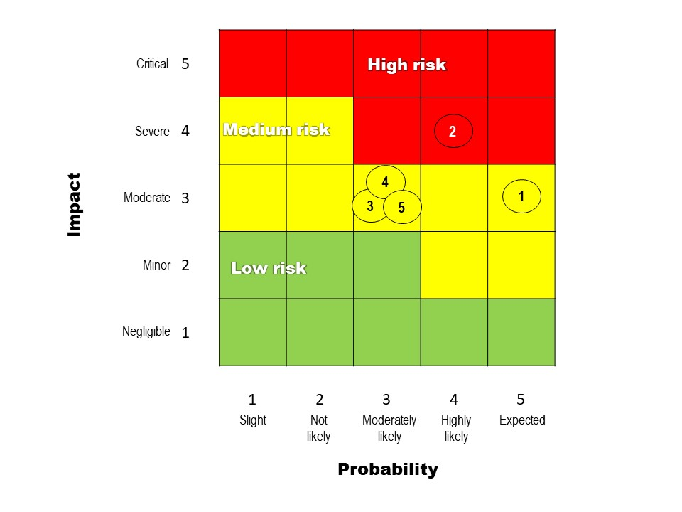
Figure 12. Magnitude of the identified risks.

A.6. Institutional Arrangement and Coordination. Describe the institutional arrangement for project implementation. Elaborate on the planned coordination with other relevant GEF-financed projects and other initiatives.

- The project will be implemented following UNDP’s national implementation modality (NIM supported), according to the Standard Basic Assistance Agreement between UNDP and the governments of Colombia and Ecuador, and the Country Programme. The host country will be Ecuador.
- The Implementing Partner for this project is the Water Secretariat of Ecuador (SENAGUA) and the Ministry of Environment and Sustainable Development (MADS) in Colombia. The Implementing Partner is responsible and accountable for managing this project, including the monitoring and evaluation of project interventions, achieving project outcomes, and for the effective use of UNDP resources.
- SENAGUA, as implementing partner, will administer the agreed binational activities on behalf of both countries and will be the executing entity to implement the corresponding Ecuadorian national activities. In Colombia, the executing entity will the Ministry of Environment and Sustainable Development (MADS) for the corresponding Colombian national activities.
- The project partners in Colombia are (i) MADS, (ii) the Government of Nariño, (iii) CORPONARIÑO, (iv) the Institute of Hydrology, Meteorology and Environmental Studies, (v) the Ministry of Foreign Affairs and (vi) WWF-Colombia. In Ecuador, the project partners are (i) SENAGUA, (ii) the Decentralized Autonomous Government of the Carchi province, (iii) Decentralized Autonomous Government of the Imbabura province, (iv) Decentralized Autonomous Government of the Esmeraldas province, (v) the Commonwealth of northern Ecuador (MNE), (vi) INAMHI and (vii) the Ministry of Foreign Affairs.
- The project organisation structure has a project board, a technical committee and a project management unit (Figure 12).

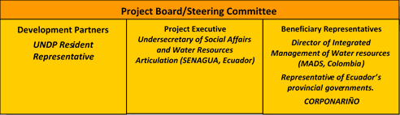
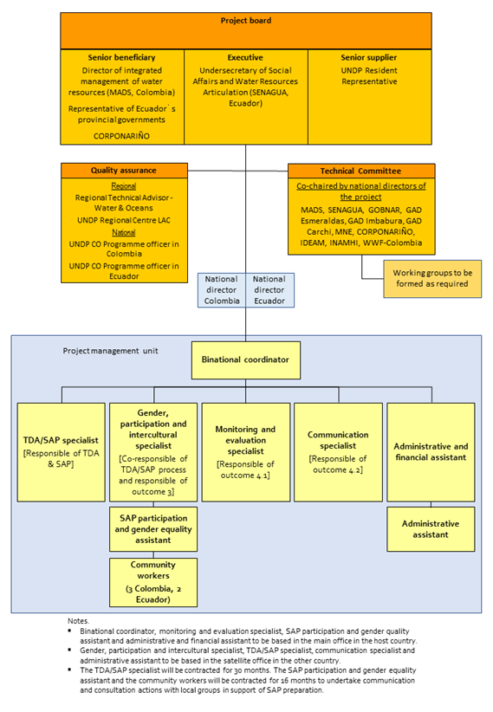

Figure 13. Project organization chart.

- The Project Board (also called Project Steering Committee) is responsible for making by consensus, management decisions when guidance is required by the project manager (here called binational coordinator), including recommendations for UNDP/Implementing Partner approval of project plans and revisions, and addressing any project level grievances. In order to ensure UNDP’s ultimate accountability, Project Board decisions should be made in accordance with standards that shall ensure management for development results, best value money, fairness, integrity, transparency and effective international competition. In case a consensus cannot be reached within the Board, final decision shall rest with the UNDP Programme Manager. The terms of reference of the Project Board are in Annex 4 of the PRODOC.
- The Project Board is formed by the following people: (i) Director of integrated management of water resources of MADS (Senior Beneficiary), (ii) a representative of Ecuador´s provincial governments (Senior Beneficiary), (iii) CORPONARIÑO (Senior Beneficiary), (iv) Undersecretary of Social Affairs and Water Resources Articulation of SENAGUA (Executive) and (v) the UNDP Resident Representative in Ecuador (Development Partner). In addition, the ministries of foreign affairs and the GEF focal points of each country will participate as observers. The UNDP Regional Technical Advisor in governance of waters and oceans will participate in the meetings as part of its quality assurance role to provide advice and guidance. The binational coordinator of the project will act as secretary of the committee, but without vote. In its first meeting, the Steering Committee will agree its operating procedures.
- The Technical Committee is an inter-institutional binational coordination space. Its main role is to provide technical guidance to the binational coordinator and the project unit in support to the achievement of the project outcomes. In addition, this entity reviews and pre-approves the annual work plans and budgets before they are submitted for consideration of the Project Board.
- The technical committee will be formed by formally designed delegates from the Government of Nariño, CORPONARIÑO, IDEAM, GAD Imbabura, GAD Esmeraldas, GAD Carchi, MNE, INAMHI, and WWF-Colombia. When appropriate, the programme officers or other UNDP specialists will participate. The members of the Technical Committee will decide on inviting other entities that consider relevant. The committee will be co-chaired by the national directors of the project in Colombia and Ecuador. In its first meeting, the Technical Committee will agree its operating procedures.
- If necessary, working groups will be established to facilitate inter-institutional coordination. The members of the committee will decide about the creation, mandate and composition of working groups.
- The National Directors of the project will be government officials formally designated by MADS in Colombia and SENAGUA in Ecuador. These persons will be responsible for the execution of the project according to what is established in the PRODOC and the approved work plans. The national directors will supervise the implementation of the national actions of the project and establish guiding and coordination actions with the Binational Coordinator, facilitate coordination and cooperation with the various relevant national entities, participate (when necessary) in the processes of recruitment / acquisition of staff, goods and services for the project, and is the person who authorizes the expenditure to be executed.
- The project management unit is headed by the binational coordinator and includes eight members (Figure 12).
- The Binational Coordinator or Project Manager (CBP) has the authority to run the project on a day-to-day basis on behalf of the Project Board within the constraints laid down by the board. The binational coordinator is responsible for day-to-day management and decision-making for the project. This person’s prime responsibility is to ensure that the project produces the results specified in the project document, to the required standard of quality and within the specified constraints of time and cost.
- The function of the CBP will finalize when the terminal evaluation report and other documentation required by GEF and UNDP have been completed and submitted to UNDP (including the operational closure of the project). The CBP will ensure fluid communication and coordination with the national directors, UNDP and the project partners, as well as other entities that contribute to project execution (e.g., local governments, civil society organizations, international cooperation). The CBP will oversee the implementation of the TDA / SAP process (outcomes 1 and 2).

Additional Information not well elaborated at PIF Stage:

A.7 Benefits. Describe the socioeconomic benefits to be delivered by the project at the national and local levels. How do these benefits translate in supporting the achievement of global environment benefits (GEF Trust Fund) or adaptation benefits (LDCF/SCCF)?

- The project will benefit a wide range of groups at local and national levels. Once the SAP is adopted by Colombia and Ecuador, the project will directly benefit about 1,160,000 persons (ca., 57% in Colombia).
- A summary of overall direct project beneficiaries includes:
- Water authorities and local governments and entities related to water conservation and management.
- Water users and in particular the water management organisations (i.e., water and irrigation boards).
- The direct beneficiaries from project actions are summarised in the following table:

Project action | Location | Country | Number | Comment
TDA / SAP process (outcomes 1 and 2) | Transboundary watersheds | Colombia | 663,519 | Population included in improved transboundary watershed management (approved SAP)
TDA / SAP process (outcomes 1 and 2) | Transboundary watersheds | Ecuador | 496,440
TDA / SAP process (outcomes 1 and 2) | Transboundary watersheds | Colombia and Ecuador | 300 | Participate in working groups and contribute to TDA and SAP development. It is anticipated that women will be >40%.
Training (outcome 3) | Transboundary watersheds | Colombia and Ecuador | 200 | Trained in various topics (water governance, hydro-diplomacy, gender)
Vermifiltration of sewage wastewater (pilot 1 output 4.1) | Cumbal municipality | Colombia | 37,635 | Connected to pilot wastewater treatment plant
Vermifiltration of sewage wastewater (pilot 1 output 4.1) | Angochagua | Ecuador | 3,768 | Connected to pilot wastewater treatment plant
Vermifiltration of sewage wastewater (pilot 1 output 4.1) | Tufiño | Ecuador | 2,339 | Connected to pilot wastewater treatment plant
Vermifiltration of sewage wastewater (pilot 1 output 4.1) | Mataje | Ecuador | 642 | Connected to pilot wastewater treatment plant
Integrated binational hydrometeorological information system (pilot 2 output 4.1) | Mira and Mataje watersheds | Colombia and Ecuador | 50,000 | Access information
Bioengineering to control landslides (pilot 3 output 4.1) | Ricaurte | Colombia | 197 | Protected from landslides
Bioengineering to control landslides (pilot 3 output 4.1) | Ricaurte | Colombia | 30 | Trained in use of vegetation to stabilise slopes.
Bioengineering to control landslides (pilot 3 output 4.1) | Ricaurte | Colombia | 1,055 | Provide plants from community forest nursery
improve performance of administrators of community rural aqueducts in Nariño | 12 municipalities of Guambuyaco and Obando subregions | Colombia | 82,126 | Population served by community rural aqueducts

A.8 Knowledge Management. Elaborate on the knowledge management approach for the project, including, if any, plans for the project to learn from other relevant projects and initiatives (e.g. participate in trainings, conferences, stakeholder exchanges, virtual networks, project twinning) and plans for the project to assess and document in a user-friendly form (e.g. lessons learned briefs, engaging websites, guidebooks based on experience) and share these experiences and expertise (e.g. participate in community of practices, organize seminars, trainings and conferences) with relevant stakeholders.

- Knowledge management is a key element of the project strategy. The project will build upon the experience and lessons from former projects (e.g., Sur Sostenible an initiative of the GEF-6 Colombian small grants programme) and ongoing initiatives (e.g., five MacArthur funded projects working on the Mira and Mataje transboundary basins). Relevant projects were mapped during project preparation.
- A series of coordination mechanisms will be established with the existing initiatives and projects and those that will develop later. These include:
- Annual coordination meetings with relevant GEF projects and initiatives from other donors.
- Participation in International Water Conferences (IWC).
- Letters of understanding with projects and relevant initiatives of other donors.
- The project will identify, analyse and share the learning that could be beneficial for the design and implementation of similar projects and the lessons will be widely disseminated. The lessons from the project will be collected into three documents which systematise experiences:
- Application of the TDA / SAP process in the three transboundary watersheds.
- Advancing governance in the transboundary watersheds.
- Visibility and strengthening of the role of women in water management.
- These documents will be (i) in a dissemination format (e.g., visually appealing, plain language) to be accessible to a wide audience, and (ii) available to be downloaded from the web. Each document will include summaries in Spanish, Awá pit, Kichwa and English.
- In addition, a memoir of the project that systematises both achievements and learnings will be prepared. The memoir will be in a simple and very graphic format, so that it is accessible to the general public. The document will have executive summaries in Spanish, Awá pit, Kichwa and English and it will be available to be downloaded from the web.

B. Description of the consistency of the project with:
B.1 Consistency with National Priorities. Describe the consistency of the project with national strategies and plans or reports and assessments under relevant conventions such as NAPAs, NAPs, ASGM NAPs, MIAs, NBSAPs, NCs, TNAs, NCSAs, NIPs, PRSPs, NPFE, BURs, etc.:

- At the regional level, the project is in line with:
- The binational plan for the integration zone that was adopted in 2014 (DNP & SENPLADES, 2017).
- The binational plan for integrated water management for the three transboundary basins (MINAMBIENTE & SENAGUA. 2017). This plan is very general and is not being implemented. Therefore, the TDA/SAP process will allow to prepare a much more robust and participatory plan with strong ownership that is formally endorsed by both governments.
- The ongoing work of the Colombo - Ecuadorian Neighbourhood and Integration Commission, which has a Binational Technical Committee on Environmental Affairs that includes a watershed working group.
- In Colombia, the project is in line and will contribute to the implementation of the following instruments:
- National policy for integrated water resources management (2010-2022) adopted in 2010.
- National policy for the integrated management of biodiversity and its ecosystem services of 2011 and its corresponding action plan 2016 - 2030.
- National policy on climate change of 2016 and the corresponding National Climate Change Adaptation Plan of 2012.
- In Ecuador, the project is in line and will contribute to the implementation of the following instruments:
- Organic law on water resources and uses issued on 2014 and the instruments that implement it (e.g., procedures to establish water boards, creation of the committee on water economy).
- National biodiversity strategy 2015 – 2030 adopted in 2015.
- National policy on Andean ecosystems of 2009.
- State policy on climate change adaptation and mitigation enacted on 2009 and amended on 2010.
- National strategy for climate change 2012-2025 adopted in 2012.

C. Describe the budgeted m &e plan:
- The project results as outlined in the project results framework will be monitored annually and evaluated periodically during project implementation to ensure the project effectively achieves these results. Supported by outcome 4.1, the project monitoring and evaluation plan will also facilitate learning and ensure knowledge is shared and widely disseminated to support the scaling up and replication of project results.
- Project-level monitoring and evaluation will be undertaken in compliance with UNDP requirements as outlined in the UNDP programme and operations policies and procedures (POPP) and the UNDP Evaluation Policy. The UNDP Country Office will work with the relevant project stakeholders to ensure UNDP M&E requirements are met in a timely fashion and to high quality standards. Additional mandatory GEF-specific monitoring and evaluation requirements (as outlined below) will be undertaken in accordance with the GEF monitoring and evaluation policy and other relevant GEF policies.
- In addition to these mandatory UNDP and GEF M&E requirements, other M&E activities deemed necessary to support project-level adaptive management will be agreed during the Project Inception Workshop and will be detailed in the Inception Report. This will include the exact role of project target groups and other stakeholders in project monitoring and evaluation activities including the GEF Operational Focal Point and national/regional institutes assigned to undertake project monitoring. The GEF Operational Focal Point will strive to ensure consistency in the approach taken to the GEF-specific M&E requirements (notably the GEF Tracking Tools) across all GEF-financed projects in the country. This could be achieved for example by using one national institute to complete the GEF Tracking Tools for all GEF-financed projects in the country, including projects supported by other GEF Agencies.
- The following table summarise the mandatory GEF monitoring and evaluation requirements and the corresponding monitoring and evaluation budget:
GEF M&E requirements | Primary responsibility | Indicative costs to be charged to the Project Budget (USD) |  | Time frame
GEF M&E requirements | Primary responsibility | GEF grant | Co-financing | Time frame
Inception Workshop | UNDP Country Office in Ecuador | USD11,200 | USD10,000 | Within two months of project document signature
Inception Report | Binational coordinator | None | None | Within two weeks of inception workshop
Standard UNDP monitoring and reporting requirements as outlined in the UNDP POPP | UNDP Country Office in Ecuador | None | None | Quarterly, annually
Risk management | Binational coordinator  UNDP Country Offices in Colombia and Ecuador | None | None | Quarterly, annually
Monitoring of indicators in project results framework | Binational coordinator | USD16,000 | USD16,000 | Annually before PIR
GEF Project Implementation Report (PIR) | Binational coordinator, UNDP Country Office in Ecuador and UNDP-GEF team | None | None | Annually
Lessons learned and knowledge generation | Binational coordinator | None | None | Annually
Monitoring of environmental and social risks, and corresponding management plans as relevant | Binational coordinator, Gender, participation and intercultural specialist and UNDP Country Office in Ecuador | USD16,000 | None | On-going
Stakeholder Engagement Plan | Binational coordinator, Gender, participation and intercultural specialist and UNDP Country Office in Ecuador | None | None | On-going
Gender Action Plan | Binational coordinator, Gender, participation and intercultural specialist and UNDP Country Office in Ecuador | None | None | On-going
Addressing environmental and social grievances | Binational coordinator, UNDP Country Office in Ecuador and Project Board | None | None | On-going
Project Board meetings | Project Board  UNDP Country Office in Ecuador  Binational coordinator | USD6,000 | USD20,000 | At minimum annually
Supervision missions | UNDP Country Office in Ecuador | None | USD10,000 | Annually
Oversight missions | UNDP-GEF team | None88 | USD10,000 | Troubleshooting as needed
GEF Secretariat learning missions/site visits | UNDP Country Office in Ecuador, Binational coordinator and UNDP-GEF team | None | USD10,000 | To be determined.
Mid-term update of GEF core indicators | Binational coordinator | USD 10,000 | None | Before mid-term review mission takes place.
Independent Mid-term Review (MTR) and management response | UNDP Country Office in Ecuador, project team and UNDP-GEF team | USD36,000 | USD5,000 | Between 2nd and 3rd PIR.
Terminal update of GEF core indicators | Binational coordinator | USD 10,000 | None | Before terminal evaluation mission takes place
Independent Terminal Evaluation (TE) included in UNDP evaluation plan, and management response | UNDP Country Office in Ecuador, project team and UNDP-GEF team | USD48,000 | USD5,000 | At least three months before operational closure
TOTAL indicative COST  Excluding project team staff time, and UNDP staff and travel expenses |  | USD 153,200 (3.97% of GEF grant) | USD86,000

- The main monitoring and evaluation reports to be generated are:

[1] Inception report. There will be an inception workshop after (i) the project document has been signed by the corresponding parties of each country, and (ii) the binational project coordinator has been hired. The inception workshop will serve to:
- Orient the project stakeholders in the project strategy and discuss changes in the general context that may influence project implementation.
- Discuss the roles and responsibilities of the project team, including reporting and communication lines, and mechanisms for conflict resolution.
- Review the results framework and, if pertinent, adjust the indicators, means of verification and monitoring plans.
- Discuss reporting, monitoring and evaluation roles and responsibilities, and if pertinent, adjust the monitoring and evaluation budget, identify national / regional entities that could be involved in the monitoring and evaluation actions of the project, discuss the role of the GEF operational focal points in project monitoring and evaluation.
- Update and review responsibilities for monitoring project plans and strategies, including the risk log, safeguards requirements, gender plan and communication strategy.
- Review financial reporting procedures and mandatory requirements and agree on the arrangements for the annual audit.
- Plan and schedule the meetings of the Steering Committee and finalize the annual work plan for the first year.
The binational project coordinator will prepare the inception report no later than two weeks after the inception workshop. The final version of the inception report will be cleared by the UNDP country office in Chile and the UNDP-GEF Regional Technical Advisor, and then approved by the Steering Committee.

[2] GEF project implementation report (PIR). The binational coordinator of the project, the UNDP country offices in Ecuador and Colombia, and the UNDP-GEF Regional Technical Advisor will provide objective inputs to the annual GEF PIR covering the reporting period July (of the previous tear) to June (of the current year). The binational project coordinator will ensure that the indicators included in the project results framework are monitored annually well in advance of the PIR submission deadline, and they are adequately reported in the GEF project implementation report. The PIR that is submitted to the GEF every year must be in English and it will be presented to the project Steering Committee. The UNDP country office in Ecuador will coordinate as necessary, the inputs for the PIR of the GEF operational focal point and other key stakeholders. The quality rating of the previous year’s PIR will be used to inform the preparation of the subsequent PIR. The final PIR of the project, together with the report of the terminal evaluation and the corresponding management response will be the final package of the project report. The final report project package will be analysed with the Steering Committee of the project during the final review meeting to identify lessons learned and opportunities to expand the outcomes.

[3] GEF core indicators. In line with its objective and the corresponding focal areas / GEF programmes, the present project will apply the GEF-7 core indicators. The baseline core indicators are presented in Annex 2 of the PRODO. The status of the core indicators will be updated by the binational project coordinator and handed to the consultants responsible of the midterm review and the terminal evaluation, before the beginning of the respective review / evaluation missions take place. The updated core indicators will be presented to the GEF together with the midterm review and terminal evaluation reports.

[4] Independent midterm review (MTR). The independent midterm review process will begin after the second PIR has been submitted to the GEF. The final MTR report will be submitted to the GEF in the same year as the third PIR. The MTR findings and the management response will be incorporated as recommendations to improve the implementation during the last half of the project´s duration. The terms of reference, the review process and the final report of the MTR will follow the standard formats and guidelines of the UNDP Independent Evaluation Office (UNDP, 2014). As stipulated in the guide for the MTR, the review will be “independent, impartial and rigorous”. The consultants hired for this task will be independent from the entities that participated in the design, implementation or advising of the project. The GEF operational focal points of Chile and Peru will be consulted during the review process. The final MTR report will be available in English and Spanish and will be cleared by the UNDP country office in Ecuador and by the PNUD-GEF Regional Technical Advisor and approved by the project board.

[5] Terminal evaluation (TE). An independent terminal evaluation will be carried out once most of the outputs and activities have been completed. The terminal evaluation process will begin three months before the operational closure of the project, facilitating that the evaluation mission acts while the project team is still operating, but making sure that the project is close enough to its conclusion, so that the evaluation team reach conclusions on key aspects such as the sustainability of the outcomes achieved. It is expected that the terminal evaluation is performed in the third quarter of the fourth year of the project, and that the operational closure is carried out during the last quarter of the same year (Annex 1 of the PRODOC). The binational project coordinator will remain on contract until the TE report and the management responses have been finalized. The terms of reference terms, the evaluation process and the final TE report will follow the standard formats and guidelines of the UNDP Independent Evaluation Office (UNDP, 2012). As stipulated in the guide for the terminal evaluation, the review will be “independent, impartial and rigorous”. The consultants hired for this task will be independent from the entities that participated in the design, implementation or advising of the project. The GEF operational focal points of Colombia and Ecuador will be consulted during the terminal evaluation process. Additional quality assurance support will be available from the UNDP-GEF directorate. The terminal evaluation report will be cleared by the UNDP country office in Ecuador and the UNDP-GEF Regional Technical Advisor and approved by the project board. The TE report will be available to the public in English on the UNDP Evaluation Resource Centre (ERC). The UNDP country office in Chile will include the project terminal evaluation within the country office evaluation plan and will upload the final report of the terminal evaluation in English to the UNDP Evaluation Resource Centre, as well as the corresponding management response. Once the documents have been uploaded to the ERC, the UNDP Independent Evaluation Office will perform a quality evaluation and will validate findings and grades that are in the TE and will rate the quality of the TE report. The UNDP independent evaluation office assessment report will be sent to the GEF independent evaluation office together with the terminal evaluation report. The UNDP country office in Ecuador will retain all monitoring and evaluation records of the present project for up to seven years after its financial closure to support ex-post evaluations that can be carried out by the UNDP independent evaluation office and/or the GEF independent evaluation office.

[6] Final report. The last PIR of the project together with the terminal evaluation report and the corresponding management response will serve as the final project report package. The final project report package will be analysed with the project board during an end-of-project review meeting to examine lessons learned and opportunities to enhance the outcomes.

PART iII: certification by gef partner agency(ies)
- GEF Agency(ies) certification
This request has been prepared in accordance with GEF policies and procedures and meets the GEF criteria for CEO endorsement under GEF-6.

Agency Coordinator, Agency Name | Signature | Date  (MM/dd/yyyy) | Project Contact Person | Telephone | Email Address
Pradeep Kurukulasuriya – Executive Coordinaor UNDP-GEF |  |  | Andrew Hudson, Head Water and Ocens, UNDP-GEF |  | Andrew.hudson@undp.org

ANNEX A: PROJECT RESULTS FRAMEWORK (either copy and paste here the framework from the Agency document or provide reference to the page in the project document where the framework could be found).

This project will contribute to the following Sustainable Development Goal (s):
SDG 6 Clean water and sanitation. Direct contribution to targets 6.5 and 6. B and some contribution to target 6.3.
SDG 15 Life on land. Direct contribution to targets 15.1 and 15.9.

This project will contribute to the following country outcome included in the UNDAF/Country Programme Document:
Colombia. UNDAF 2015-2019. Outcome environmental sustainability. Colombia will have succeeded in increasing resilience and socio-environmental sustainability to address the effects of climate change, make sustainable use of natural resources and effectively manage disaster risks.
Ecuador. UNDAF 2019-2022. Outcome 2. By 2022, Ecuador has strengthened its regulatory, political and institutional frameworks to improve sustainable, participatory and gender-sensitive management of natural resources, promoting more responsible patterns of production and consumption, in a context of climate change.
Indicator 2.8. Number of public policy instruments designed and / or implemented at the national or local level to promote the environmental sustainability of the country, on issues of sustainable use of natural resources and biodiversity conservation, climate change, management of chemicals and hazardous waste, international waters and the promotion of renewable energies. Include, through public policy for the mainstreaming of education for sustainable development.
Baseline 11. Target 38
This project will be linked to the following output of the UNDP Strategic Plan:
Output 1.4.1 Solutions scaled up for sustainable management of natural resources, including sustainable commodities and green and inclusive value chains.
Output indicator c. Number of shared water ecosystems (fresh or marine) under cooperative management.

 | Objective and Outcome Indicators  (no more than a total of 15 -16 indicators) | Baseline | Midterm Target | End of Project Target | Data Collection Methods and Risks/Assumptions
Project Objective:  To promote integrated water resources management (IWRM) in the Mira, Mataje and Carchi-Guáitara river basins shared by Colombia and Ecuador by strengthening the institutional and managerial capacities at the regional, local and community levels for achieving environmental and socioeconomic benefits. | Mandatory Indicator 1: Number of shared water ecosystems (fresh or marine) under cooperative management between Colombia and Ecuador. | 0 | 0 | 3 transboundary watersheds (Mira, Mataje and Carchi-Guáitara) | Presidential declarations, reports of binational cabinet meetings or formal instrument adopting the SAP.
Risks:
- Security risks in the target area hinder project implementation.
- Complex security environment in the target area result in tension between both governments.
Assumptions:
- Both countries maintain their political commitment to advance collaborative management of transboundary water resources.
- It is a priority in the political agenda of both countries to address the major anthropogenic pressures that negatively affect the three transboundary watersheds.
- There is good communication and collaboration among government agencies and local governments in both countries.
- The changes resulting from the national and local elections do not affect working relations and commitments.
 | Mandatory indicator 2: Number of direct project beneficiaries. | 0 | >50,000 (beneficiaries of pilot interventions and project actions) | >1,160,000 when SAP is approved | Census results and population projections for overall population per transboundary watershed. Record of persons that participate in project actions; to be continuously documented.
Risks:
Same as above.
Assumptions:
Same as above
 | Indicator 3:  Number of specific binational commitments to address critical aspects of conservation and sustainable use of water resources and to advance IWRM in the three transboundary basins. | 1 | 1 | >3 | Presidential declarations, reports of binational cabinet meetings or formal instruments signed by pertinent authorities (national and local authorities).
Risks:
Same as above.
Assumptions:
- Key stakeholders are motivated to advance IWRM in the transboundary basins.
- Political factors do not limit collaboration among key organizations and local and national authorities.
Outcome 1  Priority transboundary issues affecting quality and quantity of water, its vulnerability to climate change and variability and barriers for IWRM, and their immediate and root causes, have been identified, including a governance and stakeholder analysis to further inform the SAP process. | Indicator 4:  TDA approved by the Project Board. | 0 | End of second year: draft TDA is ready. | TDA approved at the beginning of year 3. | Project Board minutes.
Risks:
Key public and private organizations do not share or disclose data and information that is central to develop the TDA.
Assumptions:
- Key stakeholders are engaged and actively participate in the development of the TDA.
- The members of the TDA development team are granted sufficient time to contribute to the process by their employers.
 | Indicator 5:  Percentage of women in the TDA Development team | 0 | >40% | >40% | Means of verification:  - Register of participation in each event (physical document with signatures)  - Spreadsheet file with the records  Register participants in each event, including their name, age, sex, nationality, identity card number, telephone number, e-mail, organization (if they belong to one), and signature. Data will be compiled and systematized into an electronic spreadsheet file. Number of events each person attend will be also registered (in table format).
Risks:
Security risks in the target area limit participation of local stakeholders.
Assumptions:
Women are motivated to participate in the TDA development team.
 | Indicator 6: project specific  Percentage of people from non-state entities in the TDA Development team | 0 | >30% | >30% | Same as above
Risks:
Same as above
Assumptions:
Local groups and stakeholders are motivated to be part of the TDA development team.
Outcome 2  Priority actions required for achieving IWRM of the Mira, Mataje and Carchi-Guáitara basins identified and integrated to the binational, national and sub-national development plans in both countries. | Indicator 7:  SAP formally endorsed by the governments of Colombia and Ecuador | 0 | End of third year: core SAP elements discussed with local stakeholders. | SAP adopted at the beginning of year 4 | Project Board minutes acknowledging SAP. Presidential declarations, reports of binational cabinet meetings or formal instrument adopting the SAP.
Risks:
Complex security environment in the target area result in tension between both governments.
Assumptions:
- Both countries maintain their political commitment to advance collaborative management of transboundary water resources.
- The changes resulting from the national and local elections do not affect working relations and commitments.
 | Indicator 8:  Number of people (local key actors) involved in the SAP consultation process | 0 | As above  >150 | >250 | Means of verification:  - Register of participation in each event (physical document with signatures)  - Spreadsheet file with the records  Register participants in each event, including their name, age, sex, nationality, identity card number, telephone number, e-mail, organization (if they belong to one), and signature. Data will be compiled and systematized into an electronic spreadsheet file. Number of events each person attend will be also registered (in table format).
Risks:
Security risks in the target area impede participation of local stakeholders.
Assumptions:
- Community workers build relationships of trust with local groups.
- Political agendas and interests do not limit participation and contribution of local groups.
- People provide their personal information and sign the register book.
 | Indicator 9:  Percentage of women in the SAP Development team | 0 | >40% | >40% | Means of verification:  - Register of participation in each event (physical document with signatures)  - Spreadsheet file with the records  Register participants in each event, including their name, age, sex, nationality, identity card number, telephone number, e-mail, organization (if they belong to one), and signature. Data will be compiled and systematized into an electronic spreadsheet file. Number of events each person attend will be also registered (in table format).
Risks:
Security risks in the target area limit participation of local stakeholders.
Assumptions:
Women are motivated to participate in the SAP development team.
Outcome 3  Improved individual and institutional capacities in both countries to apply IWRM in the binational basins. | Indicator 10:  Number of government officials trained in transboundary water management | 0 | >20 | >20 | Means of verification:  - Register of participation in each event (physical document with signatures)  - Spreadsheet file with the records  Register participants in each event, including their name, age, sex, nationality, identity card number, telephone number, e-mail, organization, and signature. Data will be compiled and systematized into an electronic spreadsheet file. Number of events each person attend will be also registered (in table format).
Risks:
None
Assumptions:
Government officials (central and local governments) are motivated to engage into transboundary water management and hydro-diplomacy
 | Indicator 11:  Number of people from water and irrigation boards trained (>30% women) | 0 | >100 | >200 | Same as above
Risks:
Security risks in the target area limit participation of local stakeholders.
Assumptions:
- Members of water and irrigation boards are motivated to improve their skills.
- People provide their personal information and sign the register book.
 | Indicator 12:  Number of indigenous and Afro-descendant persons trained | 0 | >50 | >100 | Same as above
Risks:
Same as above
Assumptions:
- Indigenous peoples and afro-descendants are interested in water management and governance and motivated to participate in training activities.
- People provide their personal information and sign the register book.
 | Indicator 13:  Number of instruments for institutional and financial sustainability of training of water users | 0 | >1 | >2 (water school, technical training of water and irrigation boards) | Resolutions or collaboration agreements signed by local or national entities (e.g., municipalities, provincial government, universities) to sustain training of water users. Must include budget allocations and/or financial mechanism.
Risks:
Government expenditure cuts in Ecuador due to ongoing economic problems.
Assumptions:
Local or national entities are willing to invest in long-term efforts to improve the capacities and skills of water users.
Outcome 4.1  Integrated water resource management and sustainable land use reduce pollution, improve water use efficiency and protect/restore aquatic ecosystems in the Mira, Mataje and Carchi-Guáitara river basins and their aquifers. | Indicator 14:  The discharge of each treatment plant complies with the pertinent national standard. | 0 | >1 comply with national standards | 4 treatment plants comply with national standards (installed in Anchocagua, Cumbal, Mataje and Tufiño) | Effluent analysis done by independent laboratory at initiation of operation and every six months afterwards.
Risks:
Contributions of local groups (e.g., complementary funding, land site, sewer connections) do not materialise.
Assumptions:
Local operators adopt the new technology and adequately operate the vermifilters
 | Indicator 15:  Number of people accessing hydrometeorological information of the transboundary basins | 0 | > 5,000 visits per year | > 10,000 visits per year | Number of cumulative monthly visitors in the web-based platform. Report of the web analysis programme
Risks:
Hydrometeorological equipment can be vandalised or access to them can be hindered by security issues.
Assumptions:
- Local stakeholders are interested in using the information.
- Local stakeholders have the means to access the web-based platform.
 | Indicator 16:  Surface (ha) protected from landslides with bioengineering | 0 | >2,000 ha | 9,490 ha | Measurement of surface protected by bioengineering. Reports from WWF-Colombia.
Risks:
Security risks in the target area limit participation of local stakeholders.
Assumptions:
There are no extreme weather events during project implementation.
 | Indicator 17:  Public investment (USD) that finances improvements in water systems in Nariño | 0 | 0 | >USD2,000,000 | Confirmed funding to implement public investment project. Letter from Government of Nariño.
Risks:
Government expenditure cuts in Colombia.
Assumptions:
Elections of central and regional governments do not change interest in investing in water systems in Nariño.
Outcome 4.2  Learning generated through replicable innovative interventions supports the SAP development and decision making. | Indicator 18: project specific  Number of people (men and women, by country) who have participated in events for the dissemination of lessons and best practices (e.g., workshops, IWC) | 0 | >200 (>30% women) | >500 (>30% women) | Means of verification:  - Register of participation in each event (physical document with signatures)  - Spreadsheet file with the records  Register participants in each event, including their name, age, sex, nationality, identity card number, telephone number, e-mail, organization, and signature. Data will be compiled and systematized into an electronic spreadsheet file. Number of events each person attend will be also registered (in table format).
Risks:
Security risks in the target area limit participation of local stakeholders.
Assumptions:
Stakeholders are interested in the project´s lessons.
 | Indicator 19:  Number of visitors per month (annual average) recorded in the network of electronic platforms used to disseminate project´ learnings and best practice | Visits 0  Unique visits 0 | Visits >2000  Unique visits >1500 | Visits >4000  Unique visits >3000 | Number of monthly visitors (annual average) in each used platform (e.g., web page, You Tube channel). Report of the web analysis programme.
Risks:
None
Assumptions:
Local groups have proper access to the Internet and social networks.

ANNEX B: RESPONSES TO PROJECT REVIEWS (from GEF Secretariat and GEF Agencies, and Responses to Comments from Council at work program inclusion and the Convention Secretariat and STAP at PIF).

STAP COMMENTS

STAP comment. While acknowledging that the TDA/SAP process provides a well-understood path towards stress reduction and environmental stabilization, the project would benefit from an explicit theory of change. Key elements of the theory of change are left implicit, including the links between knowledge generation, capacity building, strategic planning, transboundary cooperation and policy, legal and institutional reforms. An explicit theory of change would help to frame the suggested actions and clarify the relationship between the components, especially their timing and interdependence, towards expected impact. Explicit articulation of underlying assumptions is also important including, critically, influence on private sector investment trends.

Response. Detailed causal chain analysis and theory of change were prepared. The proposal prepared by the PPG team was analysed by key stakeholders and project partners and adjusted according to their comments.

STAP comment. STAP appreciates that the project will be coordinated with several others within the region, especially the GEF/UNDP project Integrated Water Resources Management in the Puyango-Tumbes, Catamayo-Chira and Zarumilla Transboundary Aquifers and River Basins (GEF ID 5284), which involves Ecuador. That project has a well-developed causal chain analysis and includes benefit-sharing measures and attention to source-to-sea dynamics, both of which would be useful to include explicitly as opportunities within the present proposal. Regarding source-to-sea best practice, please consider the advice provided by STAP to the GEF at: http://www.stapgef.org/conceptual-framework-governing-and-managing-key-flows-source-seacontinuum.

Response. The comment was acknowledged. SENAGUA and UNDP brought the experience of GEF project 5284 to the project preparation process. The PRODOC includes a range of recommendations derived from the existing lessons. In addition, the experience of other projects was analysed to fine-tune the TDA / SAP process incorporating lessons and good practice. The TDA and SAP will include as a strategic axis the linkage between watershed and coastal processes. Finally, during project preparation it was discussed that Colombia and Ecuador might use an instrument like the binational commission for management of transboundary basins signed between Ecuador and Peru in 2018.

STAP comment. In addition, both countries (with other neighbours) are currently partners in the implementation of the Amazon Basin SAP (GEF ID 9770). Accordingly, at least at national level, it would be expected that relevant experience and capacity is already available as a baseline for further building on this project. However, no mention is made in the PIF of this foundational support, which STAP suggests reduces the barriers regarding governance and experience of IWRM.

Response. The comment was acknowledged. During project preparation the existing experience and capacities were mapped, including the GEF-supported Amazon process. However, the causal chain analysis and stakeholder consultations still identified profound barriers regarding water governance and IWRM in the three transboundary basins.

STAP comment. Four pilot interventions are proposed; however, little information is provided about the strategy guiding these interventions. What are the pilots likely to attempt and when, and what strategy is in place for their selection? The information provided in the Component 4 narrative gives no indication of the likely stakeholder ownership (the text just mentions stakeholders vaguely) or sequencing of these pilots within the overall TDA/SAP development process. The mention of ‘innovative technologies' and application to IWRM needs significant clarification.

Response. The pilot interventions were analysed in detail by project partners through broad stakeholder consultation. The interventions were selected by the project partners based on two main criteria: (i) innovation and (ii) generation of experience on key issues of the current scenario for strengthening IWRM in each of the basins. The three interventions are:
- Pilot 1. Implementation of domestic wastewater treatment systems using redworms (Eisenia foetida), as an alternative for the reduction of pollutant loads of residual domestic effluents in the rural parishes of Tufiño, Angochagua and Mataje in Ecuador, and the Municipality of Cumbal in Colombia. Vermifiltration is a low cost easy to operate procedure that removes organic matter and pathogens, the effluent can be used for irrigation and generate humus as a byproduct. This pilot intervention will generate lessons related to the key problem of pollution with untreated sewage.
- Pilot 2. Binational information system integration through strengthening of the hydrometeorological network at Carchi-Guáitara and Mira binational basins. The intervention aims to have real-time hydrometeorological data available to support early warning systems and as an input for decision-making through a public binational integrated display (viewer) to query data at various scales. Currently hydrometeorological data is not shared between both countries, and therefore this pilot intervention will allow to work procedures and methods to expedite data sharing.
- Pilot 3. Community bioengineering as a process of adaptation to changing climate conditions and reduction of risk in the sub-basin of the Güiza River, Nariño, Colombia. This will be a national intervention, but the lessons will be shared between the countries. This pilot will allow local groups to have practical experience on the use of native vegetation to stabilise unstable slopes. Landslides are a common consequence of the impact of ENSO.

STAP comment. Knowledge management (KM) practice is well developed within the GEF IW focal area and thus it is surprising that the relevant KM section of the PIF has been entirely omitted. The Component 4 narrative does focus on KM as its central thesis, and a commitment is made to deliver knowledge to IW: LEARN. However, STAP strongly suggests that experience from the IW: LEARN community should be drawn on early and referenced for further project design, alongside the specific project coordination intentions referred to earlier. In addition, the four pilot interventions proposed could usefully be peer reviewed before implementation through the IW: LEARN community.

Response. The comment was acknowledged. The PRODOC details knowledge management actions that cross all project interventions. The information from the IW: LEARN portal was used for project preparation. It was not possible to have the pilots peer reviewed by the international waters’ community of practitioners because of time constraints. The pilot interventions were prepared by project partners following long discussions and close collaboration with local stakeholders. The project expects to fully engage in IW:LEARN through participation in global (GEF IWCs) and regional/thematic IW:LEARN activities as appropriate, and to continue to draw from and utilize IW:LEARN resources (e.g., web site, lessons learned & experience notes, twinning, website toolkit).

COUNCIL COMMENTS

Germany´s comment 1. Please ensure that the envisaged co-financing amount, which derives from cash as well as in-kind financing by the two recipient governments, is planned realistically.

Response. Acknowledged. Co-financing contributions were worked in detail with the project partners. Local groups have committed contributions mainly to the pilot interventions.

Germany´s comment 2. The description of the outcomes 2, 3 and 4 could be more precise: in component 2, the outcome is not clearly stated; in component 3, the description of the outcome demonstrates a rather vague and technical understanding of the concept of Integrated Water Resources Management (IWRM); in component 4, innovative aspects need to be defined to ensure true innovation.

Response. Acknowledged. The scope of each outcome was revised.

Germany´s comment 3. Introducing IWRM seems to be challenging; firstly, with regard to the understanding of the concept of IWRM in the respective project countries, and secondly in view of the acceptance required for the implementation of the underlying principles of IWRM. Instead of merely stating these challenges, the full proposal could provide some insights on how to confront them in the frame of this project.

Response. Acknowledged. Indeed, there are no conditions to implement IWRM on the short term. There are core barriers that need to be addressed. Therefore, the project proposal clearly states that it cannot address the whole range of problems but will concentrate on setting the foundation to advance water governance to catalyse changes along the causal chain. The TDA/SAP will be the main tool to foster collaborative and inclusive strategic planning in the framework of IWRM at a transboundary level.

Germany´s comment 4. A section on knowledge management should be explicitly included in the full project proposal.

Response. Acknowledged. Outcome 4.2 focuses on documenting and sharing the lessons from the project and the pilot interventions.

Annex C: status of implementation of project preparation activities and the use of funds

A. Provide detailed funding amount of the PPG activities financing status in the table below:
PPG Grant Approved at PIF: $ 150,000
Project Preparation Activities Implemented | GEF/LDCF/SCCF Amount ($)
Project Preparation Activities Implemented | Budgeted Amount | Amount Spent Todate | Amount Committed
Project preparation grant to finalize the UNDP-GEF project document for project “Integrated Management of Water Resources of the Mira-Mataje and Carchi-Guáitara, Colombia – Ecuador Binational Basins” | 150,000 | 109,955.14 | 40,044.86
Total | 150,000 | 109,955.14 | 40,044.86

annex D: CALENDAR OF expected reflows (if non-grant instrument is used)

Provide a calendar of expected reflows to the GEF/LDCF/SCCF Trust Funds or to your Agency (and/or revolving fund that will be set up)

Annex E: GEF 7 Core Indicator Worksheet
Use this Worksheet to compute those indicator values as required in Part I, Table E to the extent applicable to your proposed project. Progress in programming against these targets for the program will be aggregated and reported at any time during the replenishment period. There is no need to complete this table for climate adaptation projects financed solely through LDCF and SCCF.

[PIMS 5753] [Colombia and Ecuador] [09 April 2019]

Core Indicator 1: Terrestrial protected areas created or under improved management for conservation and sustainable use (hectares)
Ha (expected at PIF) | Ha (expected at CEO ER) | Ha (achieved at MTR) | Ha (achieved at TE)
Figure at a given stage must be the sum of all figures reported under the two sub-indicators (1.1 and 1.2) for that stage.
1.1 Terrestrial protected areas newly created
Total Ha (expected at PIF) | Total Ha (expected at CEO ER) | Total Ha (achieved at MTR) | Total Ha (achieved at TE)
Figure at a given stage must be the sum of all individual PAs reported in the next table, for that stage.
Name of Protected Area | WDPA ID | IUCN Category | Total Ha (expected at PIF) | Total Ha (expected at CEO ER) | Total Ha (achieved at MTR) | Total Ha (achieved at TE)
Add rows as needed.
Name of Protected Area | METT Score at CEO ER | METT Score at MTR | METT Score at TE
Add rows as needed; ensure all relevant PAs are listed in both this and the previous table. Note no METT score at PIF.

1.2 Terrestrial protected areas under improved management effectiveness
Total Ha (expected at PIF) | Total Ha (expected at CEO ER) | Total Ha (achieved at MTR) | Total Ha (achieved at TE)
Figure at a given stage must be the sum of all individual PAs reported in the next table, for that stage.
Name of Protected Area | WDPA ID | IUCN Category | Total Ha (expected at PIF) | Total Ha (expected at CEO ER) | Total Ha (achieved at MTR) | Total Ha (achieved at TE)
Add rows as needed.
Name of Protected Area | METT Score at CEO ER | METT Score at MTR | METT Score at TE
Add rows as needed; ensure all relevant PAs are listed in both this and the previous table. Note no METT score at PIF.

Core Indicator 2: Marine protected areas created or under improved management for conservation and sustainable use (hectares)
Ha (expected at PIF) | Ha (expected at CEO ER) | Ha (achieved at MTR) | Ha (achieved at TE)
Figure at a given stage must be the sum of all figures reported under the two sub-indicators (2.1 and 2.2) for that stage.
2.1 Marine protected areas newly created
Total Ha (expected at PIF) | Total Ha (expected at CEO ER) | Total Ha (achieved at MTR) | Total Ha (achieved at TE)
Figure at a given stage must be the sum of all individual PAs reported in the next table, for that stage.
Name of Protected Area | WDPA ID | IUCN Category | Total Ha (expected at PIF) | Total Ha (expected at CEO ER) | Total Ha (achieved at MTR) | Total Ha (achieved at TE)
Add rows as needed.
Name of Protected Area | METT Score at CEO ER | METT Score at MTR | METT Score at TE
Add rows as needed; ensure all relevant PAs are listed in both this and the previous table. Note no METT score at PIF.
2.2 Marine protected areas under improved management effectiveness
Total Ha (expected at PIF) | Total Ha (expected at CEO ER) | Total Ha (achieved at MTR) | Total Ha (achieved at TE)
Figure at a given stage must be the sum of all individual PAs reported in the next table, for that stage.

Name of Protected Area | WDPA ID | IUCN Category | Total Ha (expected at PIF) | Total Ha (expected at CEO ER) | Total Ha (achieved at MTR) | Total Ha (achieved at TE)
Add rows as needed.
Name of Protected Area | METT Score at CEO ER | METT Score at MTR | METT Score at TE
Add rows as needed; ensure all relevant PAs are listed in both this and the previous table. Note no METT score at PIF.

Core Indicator 3: Area of land restored (hectares)
Ha (expected at PIF) | Ha (expected at CEO ER) | Ha (achieved at MTR) | Ha (achieved at TE)
Figure at a given stage must be the sum of all figures reported under the four sub-indicators (3.1, 3.2, 3.3 and 3.4) for that stage.
3.1 Area of degraded agricultural lands restored
Ha (expected at PIF) | Ha (expected at CEO ER) | Ha (achieved at MTR) | Ha (achieved at TE)
3.2 Area of forest and forest land restored
Ha (expected at PIF) | Ha (expected at CEO ER) | Ha (achieved at MTR) | Ha (achieved at TE)
3.3 Area of natural grass and shrublands restored
Ha (expected at PIF) | Ha (expected at CEO ER) | Ha (achieved at MTR) | Ha (achieved at TE)
3.4 Area of wetlands (including estuaries and mangroves) restored
Ha (expected at PIF) | Ha (expected at CEO ER) | Ha (achieved at MTR) | Ha (achieved at TE)

Core Indicator 4: Area of landscapes under improved practices (hectares; excluding protected areas)
Ha (expected at PIF) | Ha (expected at CEO ER) | Ha (achieved at MTR) | Ha (achieved at TE)
Figure at a given stage must be the sum of all figures reported under the four sub-indicators (4.1, 4.2, 4.3 and 4.4) for that stage.
4.1 Area of landscapes under improved management to benefit biodiversity (qualitative assessment, noncertified)
Ha (expected at PIF) | Qualitative description at PIF | Ha (expected at CEO ER) | Qualitative description at CEO ER | Ha (achieved at MTR) | Qualitative description at MTR | Ha (achieved at TE) | Qualitative description at TE
Add rows as needed.
4.2 Area of landscapes that meet national or international third-party certification and that incorporates biodiversity considerations
Ha (expected at PIF) | Type of Certification at PIF | Ha (expected at CEO ER) | Type of Certification at CEO ER | Ha (achieved at MTR) | Type of Certification at MTR | Ha (achieved at TE) | Type of Certification at TE
Add rows as needed.
4.3 Area of landscapes under sustainable land management in production systems
Ha (expected at PIF) | Description of Management Practices at PIF | Ha (expected at CEO ER) | Description of Management Practices at CEO ER | Ha (achieved at MTR) | Description of Management Practices at MTR | Ha (achieved at TE) | Description of Management Practices at TE
Add rows as needed.

4.4 Area of High Conservation Value forest loss avoided
Total Ha (expected at PIF) | Total Ha (expected at CEO ER) | Total Ha (achieved at MTR) | Total Ha (achieved at TE)
Figure at a given stage must be the sum of all individual PAs reported in the next table, for that stage. Prepare and upload file that justifies the HCVF.
Name of HCVF | Ha (expected at PIF) | Counterfactual at PIF | Ha (expected at CEO ER) | Counterfactual at CEO ER | Ha (achieved at MTR) | Ha (achieved at TE)
Add rows as needed.
***Evidence required in Portal: “Please upload docuument(s) that justifies the HCVF”***

Core Indicator 5: Area of marine habitat under improved practices to benefit biodiversity (hectares; excluding protected areas)
Ha (expected at PIF) | Ha (expected at CEO ER) | Ha (achieved at MTR) | Ha (achieved at TE)
5.1 Number of fisheries that meet national or international third-party certification that incorporates biodiversity considerations
Number of fisheries (expected at PIF) | Number of fisheries (expected at CEO ER) | Number of fisheries (achieved at MTR) | Number of fisheries (achieved at TE)
Name of Fishery | Total Ha (expected at PIF) | Type of Certification at PIF | Total Ha (expected at CEO ER) | Type of Certification at CEO ER | Total Ha (achieved at MTR) | Type of Certification at MTR | Total Ha (achieved at TE) | Type of Certification at TE
Add rows as needed.
5.2 Number of Large Marine Ecosystems with reduced pollution and hypoxia
Number of LMEs (expected at PIF) | Number of LMEs (expected at CEO ER) | Number of LMEs (achieved at MTR) | Number of LMEs (achieved at TE)
Figure at a given stage must be the total count of the LMEs listed in the next table.
Name of LME | Type of Pollution (expected at PIF) | Extent of Pollution (expected at PIF) | Type of Pollution (expected at CEO ER) | Extent of Pollution (expected at CEO ER) | Type of Pollution (achieved at MTR) | Extent of Pollution (achieved at MTR) | Type of Pollution (achieved at TE) | Extent of Pollution (achieved at TE)
Add rows as needed.

Total area under improved management (in PIF and CEO ER Table F)
Million Ha (expected at PIF) | Million Ha (expected at CEO ER)
Calculate the total by summing Core Indicators 1-5. Ensure that there is no double-counting.

Core Indicator 6: Greenhouse gas emissions mitigated (metric tons of carbon dioxide equivalent)
GHG emission type | Metric tons CO₂-eq (expected at PIF) | Metric tons CO₂-eq (expected at CEO ER) | Metric tons CO₂-eq (expected at MTR) | Metric tons CO₂-eq (expected at TE)
Expected metric tons of CO₂-e (direct)
Expected metric tons of CO₂-e (indirect)
Figure at a given stage must be the sum of all figures reported under the first two sub-indicators (6.1 and 6.2) for that stage.
6.1 Carbon sequestered or emissions avoided in the sector of Agriculture, Forestry and Other Land Use
GHG emission type | Ha (expected at PIF) | Metric tons CO₂-eq (expected at PIF) | Ha (expected at CEO ER) | Metric tons CO₂-eq (expected at CEO ER) | Ha (expected at MTR) | Metric tons CO₂-eq (expected at MTR) | Ha (expected at TE) | Metric tons CO₂-eq (expected at TE)
Expected metric tons of CO₂-e (direct)
Expected metric tons of CO₂-e (indirect)
Anticipated year | --- | [2018-2100] | --- | [2018-2100] | --- | [2018-2100] | --- | [2018-2100]
Duration of accounting | --- | [1-30] | --- | [1-30] | --- | [1-30] | --- | [1-30]

6.2 Emissions avoided outside AFOLU (Agriculture, Forestry and Other Land Use)
GHG emission type | Metric tons CO₂-eq (expected at PIF) | Metric tons CO₂-eq (expected at CEO ER) | Metric tons CO₂-eq (expected at MTR) | Metric tons CO₂-eq (expected at TE)
Expected metric tons of CO₂-e (direct)
Expected metric tons of CO₂-e (indirect)
Anticipated year | [2018-2100] | [2018-2100] | [2018-2100] | [2018-2100]
Duration of accounting | [1-20] | [1-20] | [1-20] | [1-20]
6.3 Energy saved (megajoules)
Total MJ (expected at PIF) | Total MJ (expected at CEO ER) | Total MJ (achieved at MTR) | Total MJ (achieved at TE)
Figure at a given stage must be the sum of all figures reported in the next table, for that stage.
Type of Intervention | MJ (expected at PIF) | MJ (expected at CEO ER) | MJ (achieved at MTR) | MJ (achieved at TE)
Add rows as needed.

6.4 Increase in installed renewable energy capacity per technology (megawatts).
Type of Renewable Energy | Capacity (MW; expected at PIF) | Capacity (MW; expected at CEO ER) | Capacity (MW; achieved at MTR) | Capacity (MW; achieved at TE)
[biomass, geothermal,
ocean, small hydro, solar photovoltaic, solar thermal, wind power, and storage]
Add rows as needed.

Core Indicator 7: Number of shared water ecosystems (fresh or marine) under new or improved cooperative management
Number (expected at PIF) | Number (expected at CEO ER) | Number (achieved at MTR) | Number (achieved at TE)
0 | 0 | 3 transboundary watersheds | 3 transboundary watersheds
Figure at a given stage must be the count of all water ecosystems reported under the four sub-indicators for that stage.
7.1 Level of Transboundary Diagnostic Analysis and Strategic Action Program formulation and implementation
Shared Water Ecosystem (name) | Rating (entered at PIF) | Rating (entered at CEO ER) | Rating (entered at MTR) | Rating (entered at TE)
[note that this is not an open field in the Portal, but a restricted drop-down list] | 1 = No TDA/SAP developed  2 = TDA finalized  3 = SAP ministerially endorsed  4 = SAP under implementation | 1 | 2 | 3
Add rows as needed, i.e. if more than one water ecosystem.
7.2 Level of regional legal agreements and regional management institution(s) to support its implementation
Shared Water Ecosystem (name) | Rating (entered at PIF) | Rating (entered at CEO ER) | Rating (entered at MTR) | Rating (entered at TE)
[note that this is not an open field in the Portal, but a restricted drop-down list] | 1 = No regional legal agreement, or neither institutional framework nor RMI in place  2 = Regional legal agreement under development  3 = Regional legal agreement signed and RMI in place  4 = Regional legal agreement ratified and RMI functional | 1 | 2 | 3
Add rows as needed, i.e. if more than one water ecosystem.

7.3 Level of national/local reforms and active participation of Inter-Ministerial Committees
Shared Water Ecosystem (name) | Rating (entered at PIF) | Rating (entered at CEO ER) | Rating (entered at MTR) | Rating (entered at TE)
[note that this is not an open field in the Portal, but a restricted drop-down list] | 1 = Neither national/local reforms nor IMCs  2 = National/local reforms in preparation, IMCs functional  3 = National/local reforms and IMCs in place  4 = National/local reforms/policies implemented, supported by IMCs | 1 | 2 | 2
Add rows as needed, i.e. if more than one water ecosystem.
7.4 Level of engagement in IW: LEARN through participation and delivery of key products
Shared Water Ecosystem (name) | Rating (entered at PIF) | Rating (entered at CEO ER) | Rating (entered at MTR) | Rating (entered at TE)
[note that this is not an open field in the Portal, but a restricted drop-down list] | 1 = No participation  2 = Website in line with IW: LEARN guidance active  3 = As above, plus strong participation in training/twinning events and production of at least one experience note and one results note  4 = As above, plus active participation of project staff and country representatives at International Waters conferences and the provision of spatial data and other data points via project website | 1 | 3 | 4
Add rows as needed, i.e. if more than one water ecosystem.

Core Indicator 8: Globally over-exploited fisheries moved to more sustainable levels (metric tons)
Metric tons marine  capture fisheries (expected at PIF) | Metric tons marine  capture fisheries (expected at CEO ER) | Metric tons marine  capture fisheries (achieved at MTR) | Metric tons marine  capture fisheries (achieved at TE)
Fishery Details (source for the estimate of tonnage, and the initial justification for considering the fishery to be overexploited)

Core Indicator 9: Reduction, disposal/destruction, phase out, elimination and avoidance of chemicals of global concern and their waste in the environment and in processes, materials, and products (metric tons of toxic chemicals reduced)
Total metric tons (expected at PIF) | Total metric tons (expected at CEO ER) | Total metric tons (achieved at MTR) | Total metric tons (achieved at TE)
Figure at a given stage must be the sum of all figures reported under the first three sub-indicators (9.1, 9.2 and 9.3) for that stage.
9.1 Solid and liquid Persistent Organic Pollutants (POPs) and POPs containing materials and products removed or disposed (POPs type)
POPs type | Metric tons (expected at PIF) | Metric tons (expected at CEO ER) | Metric tons (achieved at MTR) | Metric tons (achieved at TE)
9.2 Quantity of mercury reduced (metric tons)
Metric tons (expected at PIF) | Metric tons (expected at CEO ER) | Metric tons (achieved at MTR) | Metric tons (achieved at TE)
9.3 Hydrochlorofluorocarbons reduced/phased out (metric tons)
Metric tons (expected at PIF) | Metric tons (expected at CEO ER) | Metric tons (achieved at MTR) | Metric tons (achieved at TE)
9.4 Number of countries with legislation and policy implemented to control chemicals and waste (use this sub-indicator if one or more of 9.1, 9.2 and 9.3 are filled in)
Number (expected at PIF) | Number (expected at CEO ER) | Number (achieved at MTR) | Number (achieved at TE)
9.5 Number of low-chemical/non-chemical systems implemented, particularly in food production, manufacturing, and cities (use this sub-indicator if one or more of 9.1, 9.2 and 9.3 are filled in)
Number (expected at PIF) | Number (expected at CEO ER) | Number (achieved at MTR) | Number (achieved at TE)
9.6 Quantity of POPs/Mercury containing materials and products directly avoided
Metric tons (expected at PIF) | Metric tons (expected at CEO ER) | Metric tons (achieved at MTR) | Metric tons (achieved at TE)
NEW sub-indicator now appearing in the Portal but missing from the GEF’s Core Indicator worksheet and Results Architecture. Unclear how this is different from the headline Core Indicator 9.

Core Indicator 10: Reduction, avoidance of emissions of POPS to air from point and non-point sources (gTEQ)
Grams of toxic equivalent (expected at PIF) | Grams of toxic equivalent (expected at CEO ER) | Grams of toxic equivalent (achieved at MTR) | Grams of toxic equivalent (achieved at TE)
10.1 Number of countries with legislation and policies implemented to control emissions of POPs to air
Number (expected at PIF) | Number (expected at CEO ER) | Number (achieved at MTR) | Number (achieved at TE)
10.2 Number of emission control technologies/practices implemented
Number (expected at PIF) | Number (expected at CEO ER) | Number (achieved at MTR) | Number (achieved at TE)
Core Indicator 11: Number of direct beneficiaries disaggregated by gender as co-benefit of GEF investment
Total number (expected at PIF) | Total number (expected at CEO ER) | Total number (achieved at MTR) | Total number (achieved at TE)
 | >1,160,000 when SAP is approved | >50,000 from pilot interventions and training | >1,160,000 when SAP is approved
Figure at a given stage must be the sum of female and male, as in the table below for that stage.
Gender | Number (expected at PIF) | Number (expected at CEO ER) | Number (achieved at MTR) | Number (achieved at TE)
Female |  | 581,630
Male |  | 578,327
This indicator is mandatory for all UNDP-GEF projects.
 | Total | Male | Female
Colombia | 663,517 | 333,086 | 330,431
Ecuador | 496,440 | 245,241 | 251,199
Total | 1,159,957 | 578,327 | 581,630

Annex F: GEF Project Taxonomy Worksheet
Use this Worksheet to list down the taxonomic information required under Part I, item F by ticking the most relevant keywords/ topics/themes that best describe this project.

Level 1 | Level 2 | Level 3 | Level 4
Influencing models
 | Transform policy and regulatory environments
 | Strengthen institutional capacity and decision-making
 | Convene multi-stakeholder alliances
 | Demonstrate innovative approaches
 | Deploy innovative financial instruments
Stakeholders
 | Indigenous Peoples
 | Private Sector
 |  | Capital providers
 |  | Financial intermediaries and market facilitators
 |  | Large corporations
 |  | SMEs
 |  | Individuals/Entrepreneurs
 |  | Non-Grant Pilot
 |  | Project Reflow
 | Beneficiaries
 | Local Communities
 | Civil Society
 |  | Community Based Organization
 |  | Non-Governmental Organization
 |  | Academia
 |  | Trade Unions and Workers Unions
 | Type of Engagement
 |  | Information Dissemination
 |  | Partnership
 |  | Consultation
 |  | Participation
 | Communications
 |  | Awareness Raising
 |  | Education
 |  | Public Campaigns
 |  | Behaviour Change
Capacity, Knowledge and Research
 | Enabling Activities
 | Capacity Development
 | Knowledge Generation and Exchange
 | Targeted Research
 | Learning
 |  | Theory of Change
 |  | Adaptive Management
 |  | Indicators to Measure Change
 | Innovation
 | Knowledge and Learning
 |  | Knowledge Management
 |  | Innovation
 |  | Capacity Development
 |  | Learning
 | Stakeholder Engagement Plan
Gender Equality
 | Gender Mainstreaming
 |  | Beneficiaries
 |  | Women groups
 |  | Sex-disaggregated indicators
 |  | Gender-sensitive indicators
 | Gender results areas
 |  | Access and control over natural resources
 |  | Participation and leadership
 |  | Access to benefits and services
 |  | Capacity development
 |  | Awareness raising
 |  | Knowledge generation
Focal Areas/Theme
 | Integrated Programs
 |  | Commodity Supply Chains (Good Growth Partnership)
 |  |  | Sustainable Commodities Production
 |  |  | Deforestation-free Sourcing
 |  |  | Financial Screening Tools
 |  |  | High Conservation Value Forests
 |  |  | High Carbon Stocks Forests
 |  |  | Soybean Supply Chain
 |  |  | Oil Palm Supply Chain
 |  |  | Beef Supply Chain
 |  |  | Smallholder Farmers
 |  |  | Adaptive Management
 |  | Food Security in Sub-Sahara Africa
 |  |  | Resilience (climate and shocks)
 |  |  | Sustainable Production Systems
 |  |  | Agroecosystems
 |  |  | Land and Soil Health
 |  |  | Diversified Farming
 |  |  | Integrated Land and Water Management
 |  |  | Smallholder Farming
 |  |  | Small and Medium Enterprises
 |  |  | Crop Genetic Diversity
 |  |  | Food Value Chains
 |  |  | Gender Dimensions
 |  |  | Multi-stakeholder Platforms
 |  | Food Systems, Land Use and Restoration
 |  |  | Sustainable Food Systems
 |  |  | Landscape Restoration
 |  |  | Sustainable Commodity Production
 |  |  | Comprehensive Land Use Planning
 |  |  | Integrated Landscapes
 |  |  | Food Value Chains
 |  |  | Deforestation-free Sourcing
 |  |  | Smallholder Farmers
 |  | Sustainable Cities
 |  |  | Integrated urban planning
 |  |  | Urban sustainability framework
 |  |  | Transport and Mobility
 |  |  | Buildings
 |  |  | Municipal waste management
 |  |  | Green space
 |  |  | Urban Biodiversity
 |  |  | Urban Food Systems
 |  |  | Energy efficiency
 |  |  | Municipal Financing
 |  |  | Global Platform for Sustainable Cities
 |  |  | Urban Resilience
 | Biodiversity
 |  | Protected Areas and Landscapes
 |  |  | Terrestrial Protected Areas
 |  |  | Coastal and Marine Protected Areas
 |  |  | Productive Landscapes
 |  |  | Productive Seascapes
 |  |  | Community Based Natural Resource Management
 |  | Mainstreaming
 |  |  | Extractive Industries (oil, gas, mining)
 |  |  | Forestry (Including HCVF and REDD+)
 |  |  | Tourism
 |  |  | Agriculture & agrobiodiversity
 |  |  | Fisheries
 |  |  | Infrastructure
 |  |  | Certification (National Standards)
 |  |  | Certification (International Standards)
 |  | Species
 |  |  | Illegal Wildlife Trade
 |  |  | Threatened Species
 |  |  | Wildlife for Sustainable Development
 |  |  | Crop Wild Relatives
 |  |  | Plant Genetic Resources
 |  |  | Animal Genetic Resources
 |  |  | Livestock Wild Relatives
 |  |  | Invasive Alien Species (IAS)
 |  | Biomes
 |  |  | Mangroves
 |  |  | Coral Reefs
 |  |  | Sea Grasses
 |  |  | Wetlands
 |  |  | Rivers
 |  |  | Lakes
 |  |  | Tropical Rain Forests
 |  |  | Tropical Dry Forests
 |  |  | Temperate Forests
 |  |  | Grasslands
 |  |  | Paramo
 |  |  | Desert
 |  | Financial and Accounting
 |  |  | Payment for Ecosystem Services
 |  |  | Natural Capital Assessment and Accounting
 |  |  | Conservation Trust Funds
 |  |  | Conservation Finance
 |  | Supplementary Protocol to the CBD
 |  |  | Biosafety
 |  |  | Access to Genetic Resources Benefit Sharing
 | Forests
 |  | Forest and Landscape Restoration
 |  |  | REDD/REDD+
 |  | Forest
 |  |  | Amazon
 |  |  | Congo
 |  |  | Drylands
 | Land Degradation
 |  | Sustainable Land Management
 |  |  | Restoration and Rehabilitation of Degraded Lands
 |  |  | Ecosystem Approach
 |  |  | Integrated and Cross-sectoral approach
 |  |  | Community-Based NRM
 |  |  | Sustainable Livelihoods
 |  |  | Income Generating Activities
 |  |  | Sustainable Agriculture
 |  |  | Sustainable Pasture Management
 |  |  | Sustainable Forest/Woodland Management
 |  |  | Improved Soil and Water Management Techniques
 |  |  | Sustainable Fire Management
 |  |  | Drought Mitigation/Early Warning
 |  | Land Degradation Neutrality
 |  |  | Land Productivity
 |  |  | Land Cover and Land cover change
 |  |  | Carbon stocks above or below ground
 |  | Food Security
 | International Waters
 |  | Ship
 |  | Coastal
 |  | Freshwater
 |  |  | Aquifer
 |  |  | River Basin
 |  |  | Lake Basin
 |  | Learning
 |  | Fisheries
 |  | Persistent toxic substances
 |  | SIDS : Small Island Dev States
 |  | Targeted Research
 |  | Pollution
 |  |  | Persistent toxic substances
 |  |  | Plastics
 |  |  | Nutrient pollution from all sectors except wastewater
 |  |  | Nutrient pollution from Wastewater
 |  | Transboundary Diagnostic Analysis and Strategic Action Plan preparation
 |  | Strategic Action Plan Implementation
 |  | Areas Beyond National Jurisdiction
 |  | Large Marine Ecosystems
 |  | Private Sector
 |  | Aquaculture
 |  | Marine Protected Area
 |  | Biomes
 |  |  | Mangrove
 |  |  | Coral Reefs
 |  |  | Seagrasses
 |  |  | Polar Ecosystems
 |  |  | Constructed Wetlands
 | Chemicals and Waste
 |  | Mercury
 |  | Artisanal and Scale Gold Mining
 |  | Coal Fired Power Plants
 |  | Coal Fired Industrial Boilers
 |  | Cement
 |  | Non-Ferrous Metals Production
 |  | Ozone
 |  | Persistent Organic Pollutants
 |  | Unintentional Persistent Organic Pollutants
 |  | Sound Management of chemicals and Waste
 |  | Waste Management
 |  |  | Hazardous Waste Management
 |  |  | Industrial Waste
 |  |  | e-Waste
 |  | Emissions
 |  | Disposal
 |  | New Persistent Organic Pollutants
 |  | Polychlorinated Biphenyls
 |  | Plastics
 |  | Eco-Efficiency
 |  | Pesticides
 |  | DDT - Vector Management
 |  | DDT - Other
 |  | Industrial Emissions
 |  | Open Burning
 |  | Best Available Technology / Best Environmental Practices
 |  | Green Chemistry
 | Climate Change
 |  | Climate Change Adaptation
 |  |  | Climate Finance
 |  |  | Least Developed Countries
 |  |  | Small Island Developing States
 |  |  | Disaster Risk Management
 |  |  | Sea-level rise
 |  |  | Climate Resilience
 |  |  | Climate information
 |  |  | Ecosystem-based Adaptation
 |  |  | Adaptation Tech Transfer
 |  |  | National Adaptation Programme of Action
 |  |  | National Adaptation Plan
 |  |  | Mainstreaming Adaptation
 |  |  | Private Sector
 |  |  | Innovation
 |  |  | Complementarity
 |  |  | Community-based Adaptation
 |  |  | Livelihoods
 |  | Climate Change Mitigation
 |  |  | Agriculture, Forestry, and other Land Use
 |  |  | Energy Efficiency
 |  |  | Sustainable Urban Systems and Transport
 |  |  | Technology Transfer
 |  |  | Renewable Energy
 |  |  | Financing
 |  |  | Enabling Activities
 |  | Technology Transfer
 |  |  | Poznan Strategic Programme on Technology Transfer
 |  |  | Climate Technology Centre & Network (CTCN)
 |  |  | Endogenous technology
 |  |  | Technology Needs Assessment
 |  |  | Adaptation Tech Transfer
 |  | United Nations Framework on Climate Change
 |  |  | Nationally Determined Contribution

Project ID number remains the same as the assigned PIF number.
When completing Table A, refer to the excerpts on GEF 6 Results Frameworks for GETF, LDCF and SCCF.
Financing type can be either investment or technical assistance.
For GEF Project Financing up to $2 million, PMC could be up to10% of the subtotal; above $2 million, PMC could be up to 5% of the subtotal. PMC should be charged proportionately to focal areas based on focal area project financing amount in Table D below.
For questions A.1 –A.7 in Part II, if there are no changes since PIF , no need to respond, please enter “NA” after the respective question.
For biodiversity projects, in addition to explaining the project’s consistency with the biodiversity focal area strategy, objectives and programs, please also describe which Aichi Target(s) the project will directly contribute to achieving..
For example, forced displacement of local population and expansion of an illegal economy (e.g., provision of supplies and workforce, transportation of drugs).
Illegal gold mining has severe impacts that include deforestation, soil and water pollution as well as violation of human rights (The Global Initiative, 2016).
See Law 1450 of 2011, published in the Official Register on 16 June 2011 and ruling C-035 of 2016 of the Constitutional Court of Colombia.
See the Organic Code on the Environment (COA), published in the Official Register on 12 April 2017, and the Andean Ecosystems, issued by Acuerdo 064 published in the Official Register on 5 November 2009. The latter includes Andean forests and wetlands.
There is a densely populated urban area along the Pan-American highway that link five municipalities (Ibarra, San Miguel de Urcuqui, Antonio Ante, Cotacachi and Otavalo). In this area there is intense and diversified production (textiles, manufacturing, tourism, commerce, animal husbandry, agriculture).
In contrast, to Pastos, Otavalos and Andean Afro-descendants who have been farmers with extensive water management practice and are key members of water management units.
Prepared as part of project “Integrated and Sustainable Management of Transboundary Water Resources in the Amazon River Basin Considering Climate Variability and Climate Change” (GEF-AMAZON) (GEF ID 2364). A new project (GEF ID 9770) will support the initial implementation of the SAP.
Project “Integrated Water Resources Management in the Puyango-Tumbes, Catamayo-Chira and Zarumilla Transboundary Aquifers and River Basins” (GEF ID 5284).
Created by Law 1753 of 2015 and made operative by Decree 585 of 5 April 2017.The National Water Council initiated activities on June 2018.
Regional environmental authorities ("corporaciones autónomas regionales", CARs) are decentralised autonomous institutions in charge of implementing national policies and regulations as well as managing the natural resources in their jurisdiction (e.g., paramos, forests), included water resources. With respect to water resources, CARs: (i) allocate water to users, (ii) control water pollution, (iii) prepare and implement watershed management plans ("Planes de Ordenación y Manejo de Cuencas Hidrográficas", abbreviated as POMCA) and (iv) implement actions for ecosystem protection.
Municipal authorities are responsible for the provision of water and sanitation. In addition, the departmental governments coordinate and implement departmental water plans ("planes departamentales de agua", abbreviated PDA) that channel investments from the Ministry of Housing, City and Territory.
Community rural aqueducts are water provision systems managed by organised local groups. They (i) install and operate infrastructure to provide drinking water and (ii) elect a board to administer the water system. It has been estimated that there are about 12,000 rural aqueducts in Colombia. There are legal gaps that make them considered illegal, but at the same time receive government support to improve their capacities and service. A key issue is provision of clean water. In general, it has been found that in rural areas drinking water is not safe. MINSALUD (2018) reported that rural water in Nariño has a high Water Quality Risk Index.
In 1989 the Colombo-Ecuadorian Neighbourhood Commission was established, later in 2011 it was transformed into the Colombo - Ecuadorian Neighbourhood and Integration Commission.
The legal basis for the Colombo - Ecuadorian Integration Zone is Decision 501 of 2001 of the Andean Council of Ministers of Foreign Affairs. The border integration zone includes two departments of Colombia (Nariño and Putumayo) and four Ecuadorian provinces (Esmeraldas, Carchi, Imbabura, Sucumbíos).
See http://www.sbi-ecuador-colombia.info.
The fund is administered by the InterAmerican Development Bank and will be capitalized with national contributions (total USD 10 million per country, with annual inputs of USD2,000,000 per country).
Last binational cabinet was held in December 2018.
"Acuerdo que establece la Comisión Binacional para la Gestión Integrada de los Recursos Hídricos de las Cuencas Hidrográficas Transfronterizas entre la República del Ecuador y la República del Perú". This instrument was developed as part of the implementation of project “Integrated Water Resources Management in the Puyango-Tumbes, Catamayo-Chira and Zarumilla Transboundary Aquifers and River Basins” (GEF ID 5284).
Colombia´s Constitutional Court Auto 620 of 2017 (15 November 2017).
Decentralized Autonomous Government of the Esmeraldas province (GAD Esmeraldas), Decentralized Autonomous Government of the Imbabura province (GAD Imbabura) and Decentralized Autonomous Government of the Carchi province (GAD Carchi).
The MacArthur Foundation is funding five projects that will generate information on a range of topics, including community-led conservation, ecosystem services and water conservation (see https://www.macfound.org/grants/?q=mira-mataje). These projects focus on Mira and Mataje. The Adaptation Fund is financing a project focused on food security of indigenous and Afro-descendant communities in the three transboundary watersheds (“Building adaptive capacity through food and nutrition security and peacebuilding actions in vulnerable Afro and indigenous communities in the Colombia-Ecuador border area”, see https://www.adaptation-fund.org/project/building-adaptive-capacity-climate-change-food-security-nutrition-actions-vulnerable-afro-indigenous-communities-colombia-ecuador-border-area-colombia-ecuador-2/). This project will prepare a vulnerability analysis that will be a direct input for the TDA.
This was suggested during consultation meetings with stakeholders, to prevent that the TDA team is dominated by public entities.
These will be local persons that work directly with indigenous people. In Colombia, three community workers will work with the Awá, Pastos and Afro-descendants. In Ecuador, two persons will be hired. One to work with Awá and African-descendants and another to work with indigenous people in the highlands.
Resolution 2016-1442 of 5 December 2016.
See: - http://rpa.senagua.gob.ec/index.php/escuela-del-agua - http://186.42.121.45/escuelaagua/
The Commonwealth of northern Ecuador was established in 2011 as a mechanism for integration and development of the four northernmost provinces of Ecuador. These provinces are part of the Colombo - Ecuadorian Integration Zone.
FEWS Colombia is an online visor that show river levels and hydrological alerts (http://www.ideam.gov.co/web/agua/fews). It is operated by IDEAM and uses Delf-FEWS (Werner et al., 2013).
The Colombian General System of Royalty Payments (“Sistema General de Regalías de Colombia”, abbreviate SGR) provide funding for investment projects of the local governments.
Three meetings per pilot intervention: (i) three months after pilot initiation, (ii) at midterm, and (iii) when closing the pilot.
see https://www.macfound.org/grants/?q=mira-mataje
Environmental, Financial, Operational, Organizational, Political, Regulatory, Strategic, Others
1 = low, 5 = high.
Finished, reducing, increasing, without change.
Project staff must take the online "conflict sensitive course" at UN System Staff College and the BSAFE online course at UNDSS.
In Colombia prior consultation to ethnic groups (the term used in national regulations) is mandatory by law. However, there have been cases in which local groups request compensation in initiatives that are for their own benefit (e.g., water systems). In the present project, one of the small-scale pilot demonstrations will be implemented in a Pasto community and it is assumed that the SAP (being a binding policy and planning instrument) will require to undergo the formal prior consultation process. From known cases, the requested compensation may overpass the capacity of project proponents. Also, the prior consultation process requires specific allocations of time and funding.
The cabildos indígena are renewed every year.
i.e., SAP participation and gender equality assistant and five community workers.
During PPG, two key issues were identified: (i) women are participating with limitations in the water and irrigation organizations and (ii) they have very limited and unequal participation on decision making in the water and irrigation boards. In particular, irrigation has been a male activity, where the advances in the recognition of women are limited and their participation in organizations and decision-making processes have been unequal. Added to this is that women have domestic responsibilities and care for other members of the family and that men restrict the participation of women of their family to these spaces.
By 14 March 2019 a weak El Niño was present, weak El Niño conditions were likely to continue through the Northern Hemisphere spring 2019 (~80% chance) and summer (~60% chance). It is probable that during the implementation of the project another ENSO event will occur. This will have direct impact on the hydrological regime of the three transboundary basins.
http://web.undp.org/evaluation/policy.shtml
https://www.thegef.org/documents/policies
Excluding project team staff time and UNDP staff time and travel expenses.
Indicated in the budget as: “annual assessment of compliance with social and environmental safeguards”. See corresponding budget note.
The costs of UNDP Country Office and UNDP-GEF Unit’s participation and time are charged to the GEF Agency Fee.
http://web.undp.org/evaluation/guidance.shtml#gef
GEF policies encompass all managed trust funds, namely: GEFTF, LDCF, and SCCF
Target 6.5 By 2030, implement integrated water resources management at all levels, including through transboundary cooperation as appropriate. Target 6.B Support and strengthen the participation of local communities in improving water and sanitation management.
Target 6.3 By 2030, improve water quality by reducing pollution, eliminating dumping and minimizing release of hazardous chemicals and materials, halving the proportion of untreated wastewater and substantially increasing recycling and safe reuse globally.
Target 15.1. By 2020, ensure the conservation, restoration and sustainable use of terrestrial and inland freshwater ecosystems and their services, in particular forests, wetlands, mountains and drylands, in line with obligations under international agreements. Target 15.9. By 2020, integrate ecosystem and biodiversity values into national and local planning, development processes, poverty reduction strategies and accounts.
At least three instruments will be agreed: - Binational workplan that includes commitments to make SAP implementation viable. - Binational protocol for monitoring water quality. - Binational protocol to exchange and share hydrometeorological information of transboundary watersheds.
Outcomes are short to medium term results that the project makes a contribution towards, and that are designed to help achieve the longer-term objective. Achievement of outcomes will be influenced both by project outputs and additional factors that may be outside the direct control of the project.
i.e., Entities that are independent of the government such as civil society organizations, farmers associations or community groups.
If at CEO Endorsement, the PPG activities have not been completed and there is a balance of unspent fund, Agencies can continue to undertake the activities up to one year of project start. No later than one year from start of project implementation, Agencies should report this table to the GEF Secretariat on the completion of PPG activities and the amount spent for the activities. Agencies should also report closing of PPG to Trustee in its Quarterly Report.

